* **Java Script Comments**

**INPUT**

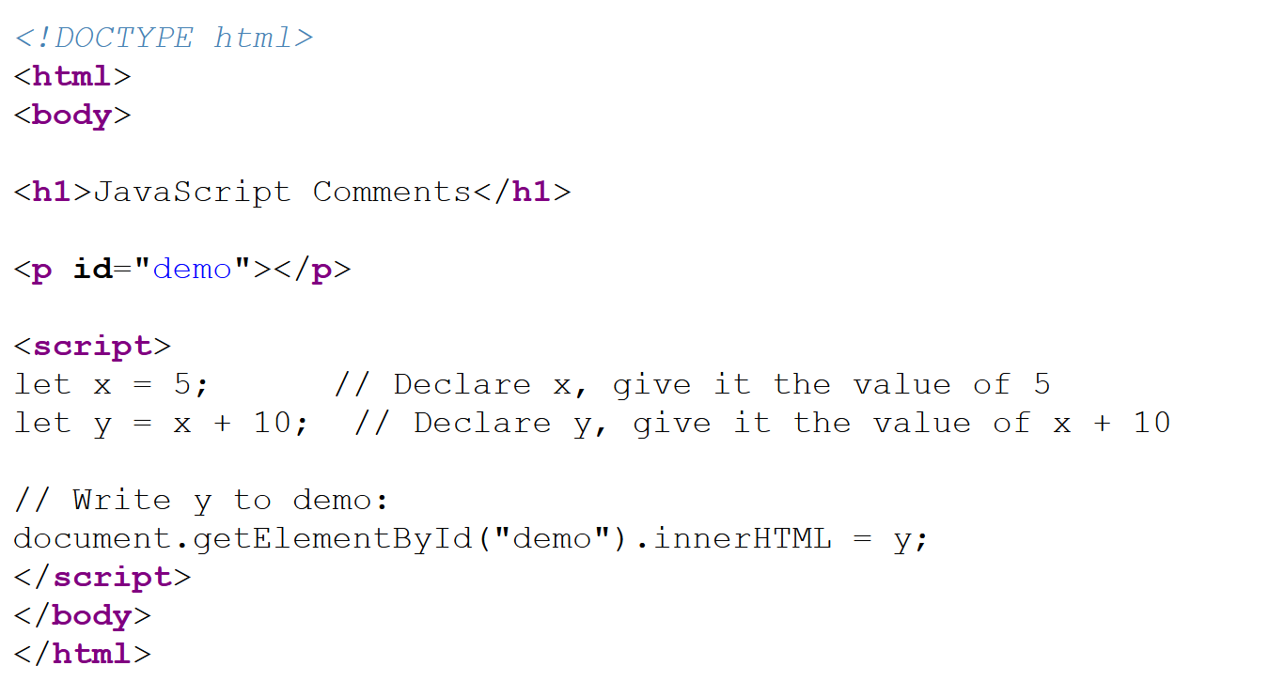

**OUTPUT**

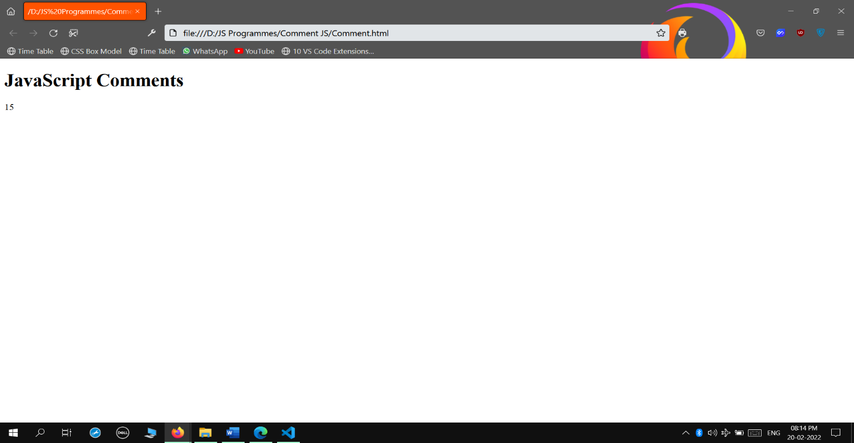

* **Java Script Variables**

**INPUT**

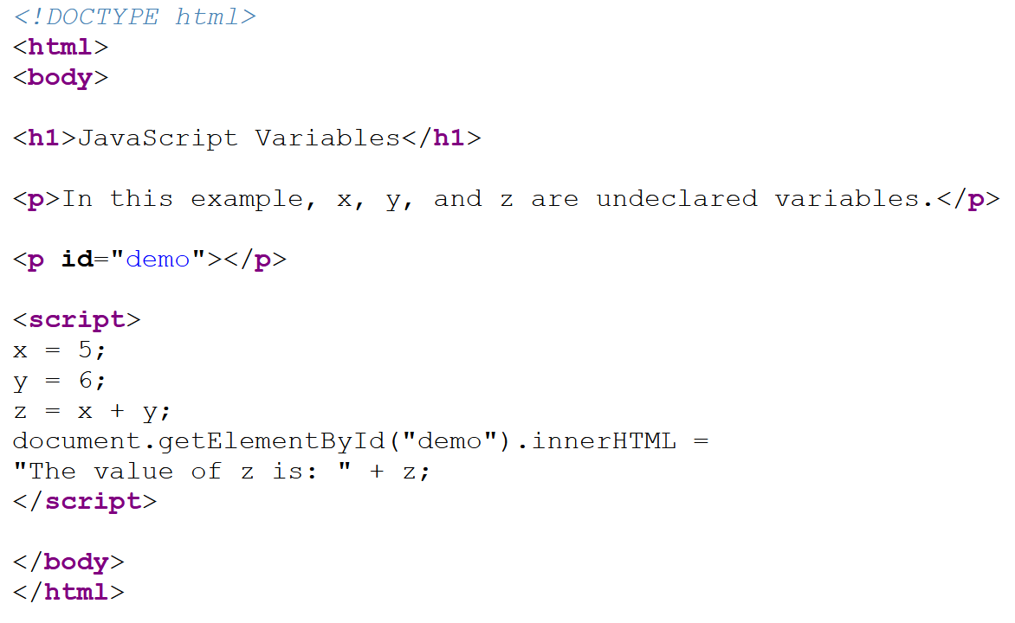

**OUTPUT**

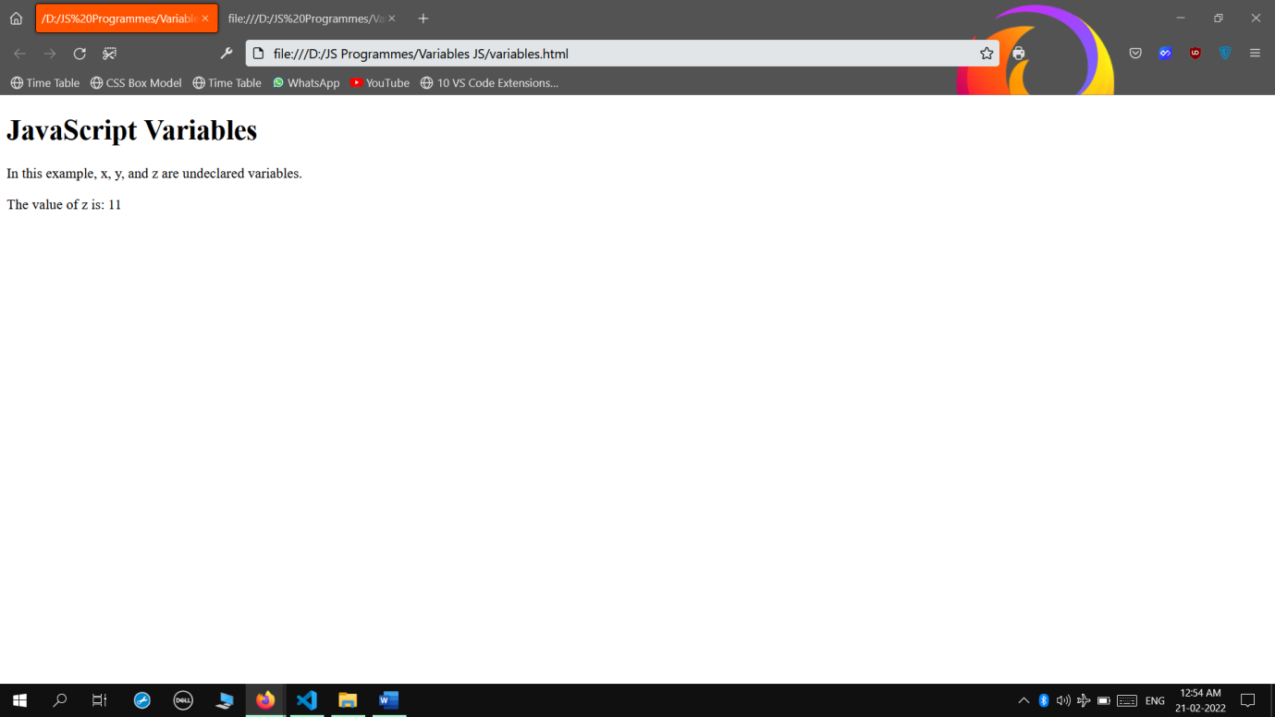

* **Java Script Variables 2**

**INPUT**

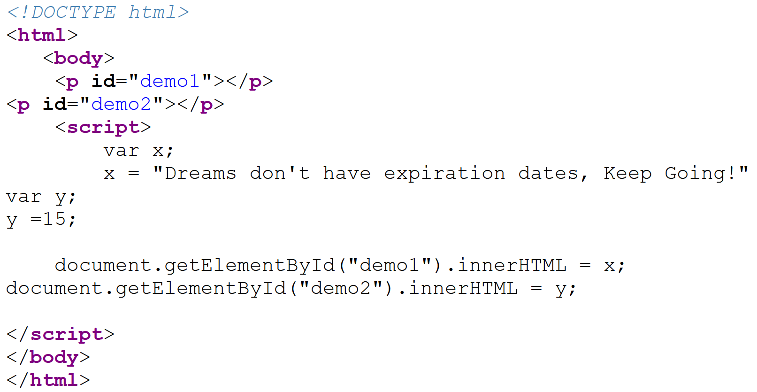

**OUTPUT**

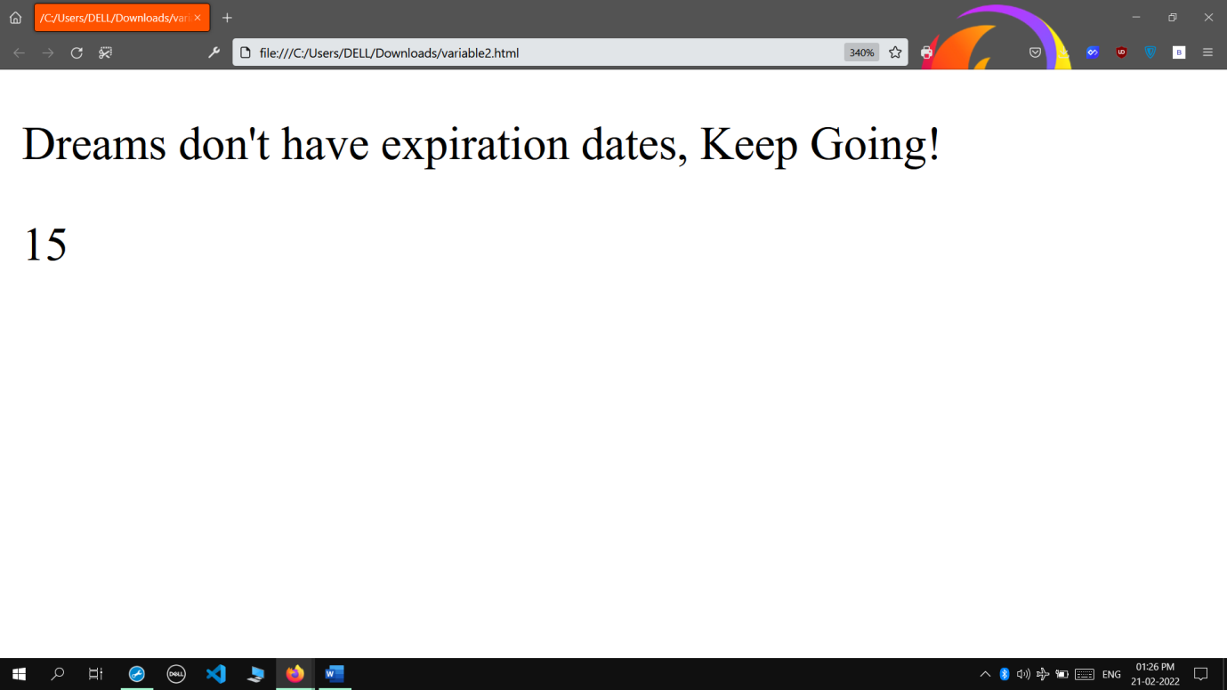

* **Java Script Variable Types**

**INPUT**

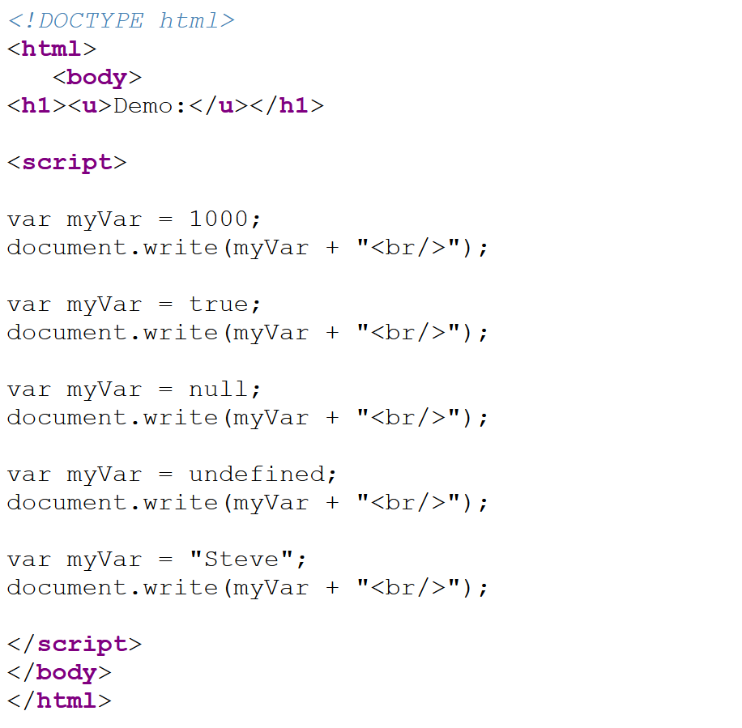

**OUTPUT**

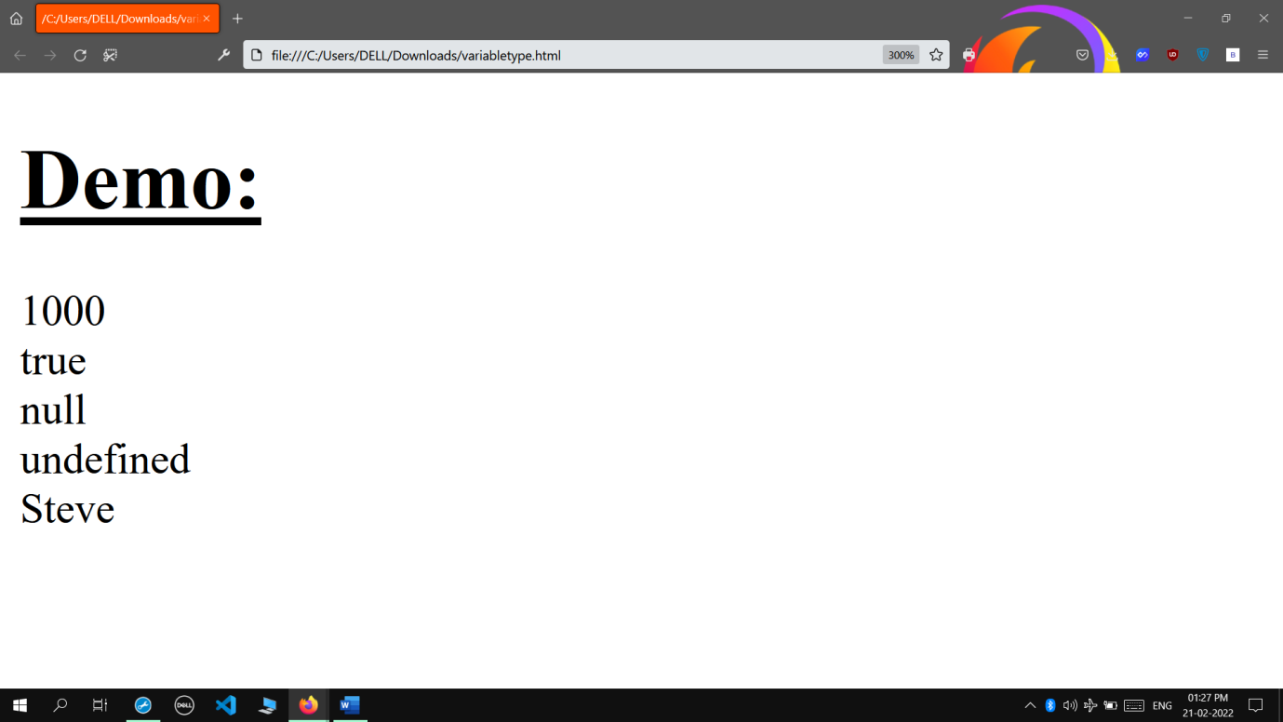

* **Java Script Expressions**

**INPUT**

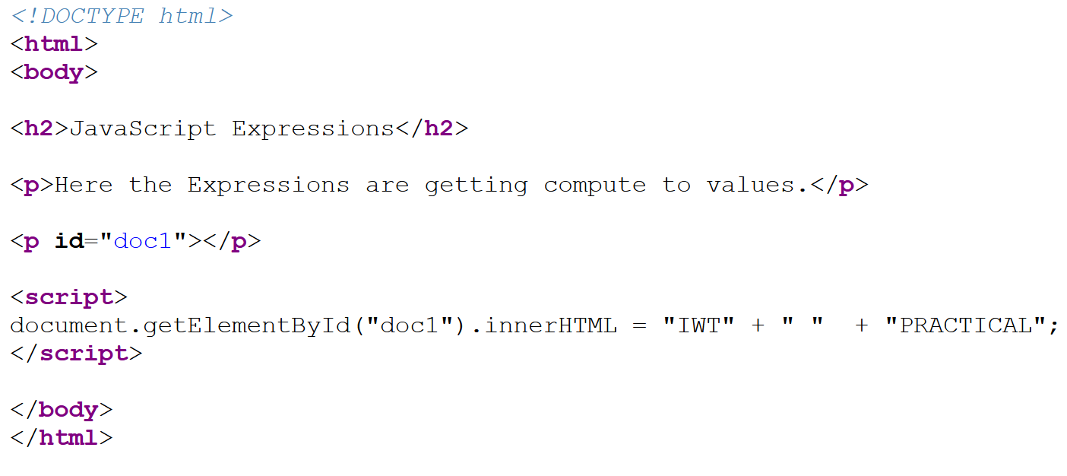

**OUTPUT**

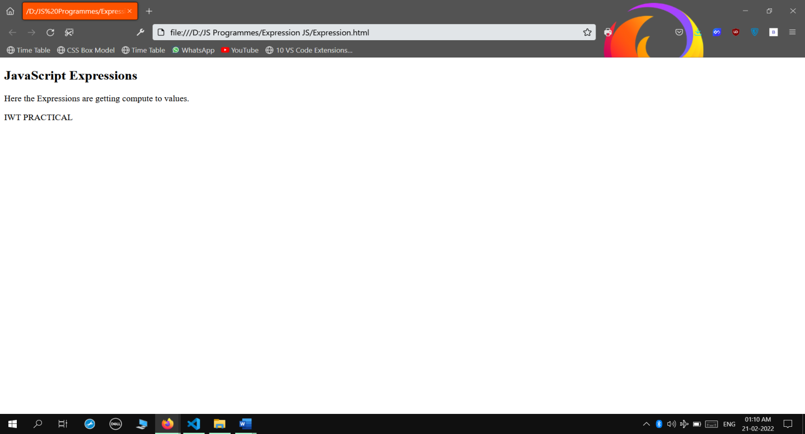

* **Java Script Conditionals**

**INPUT**

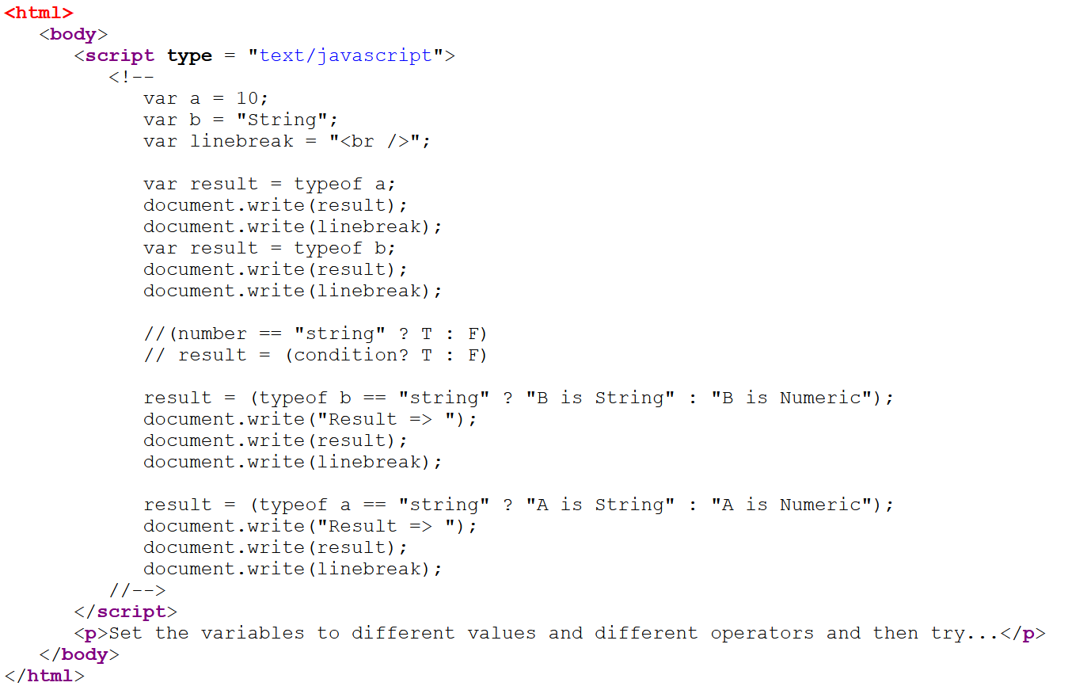

**OUTPUT**

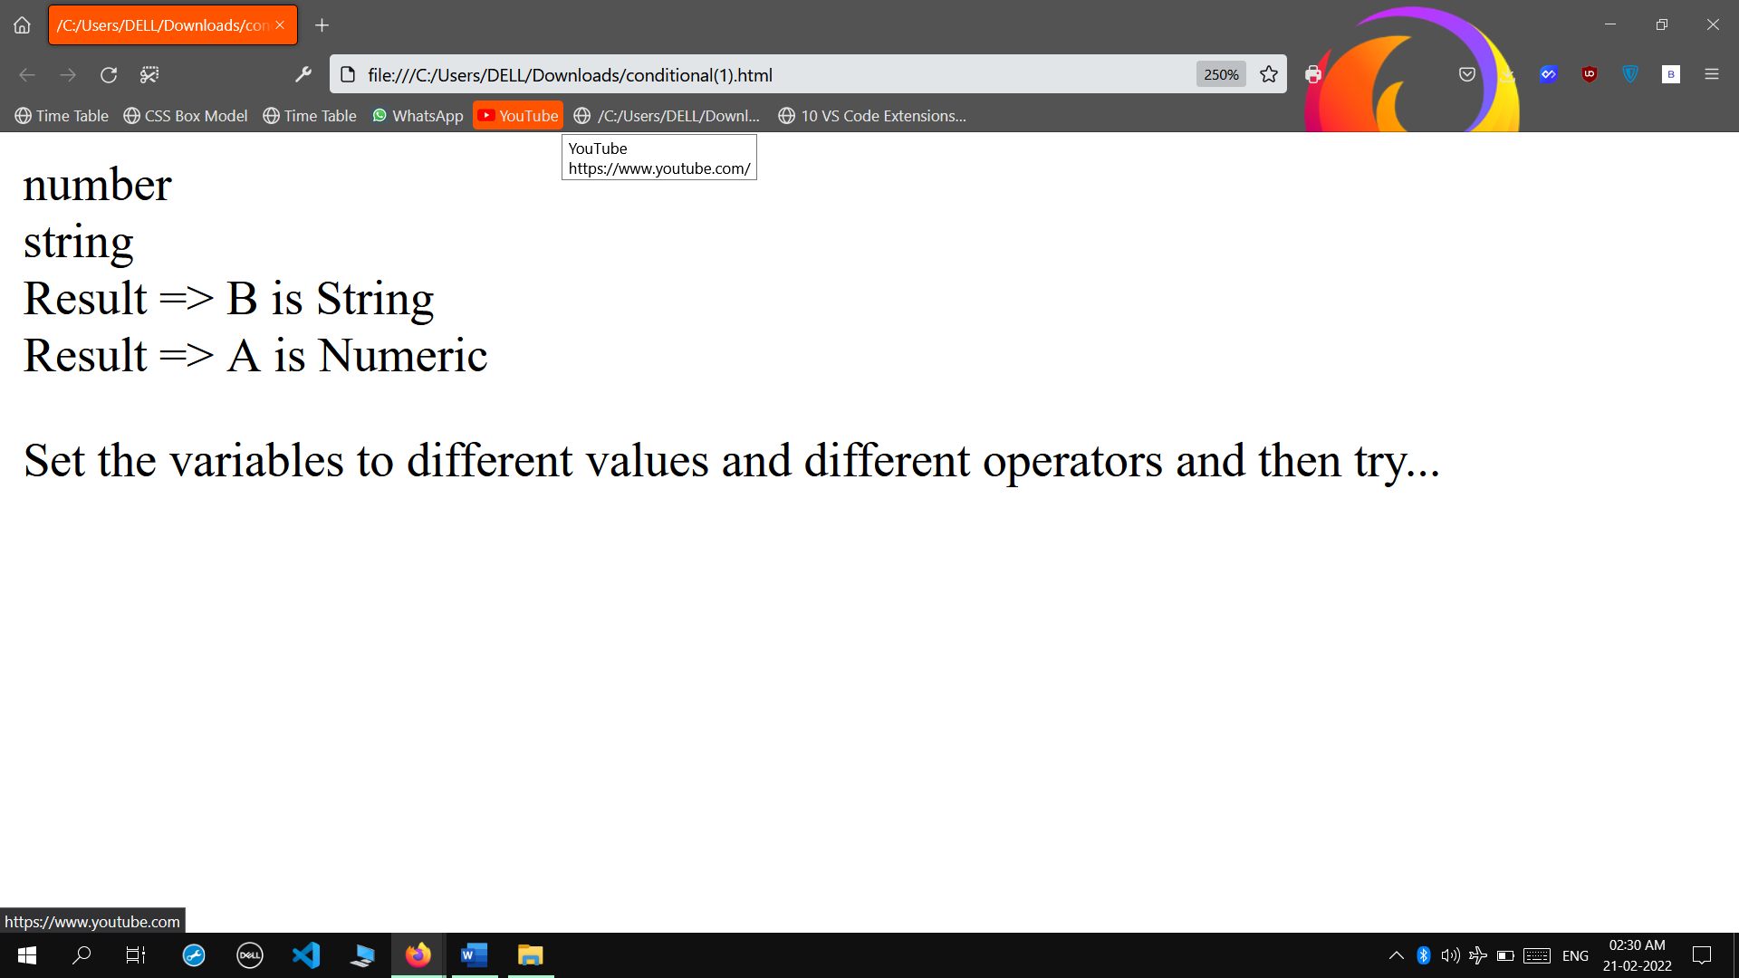

* **Java Script Objects**

**INPUT**

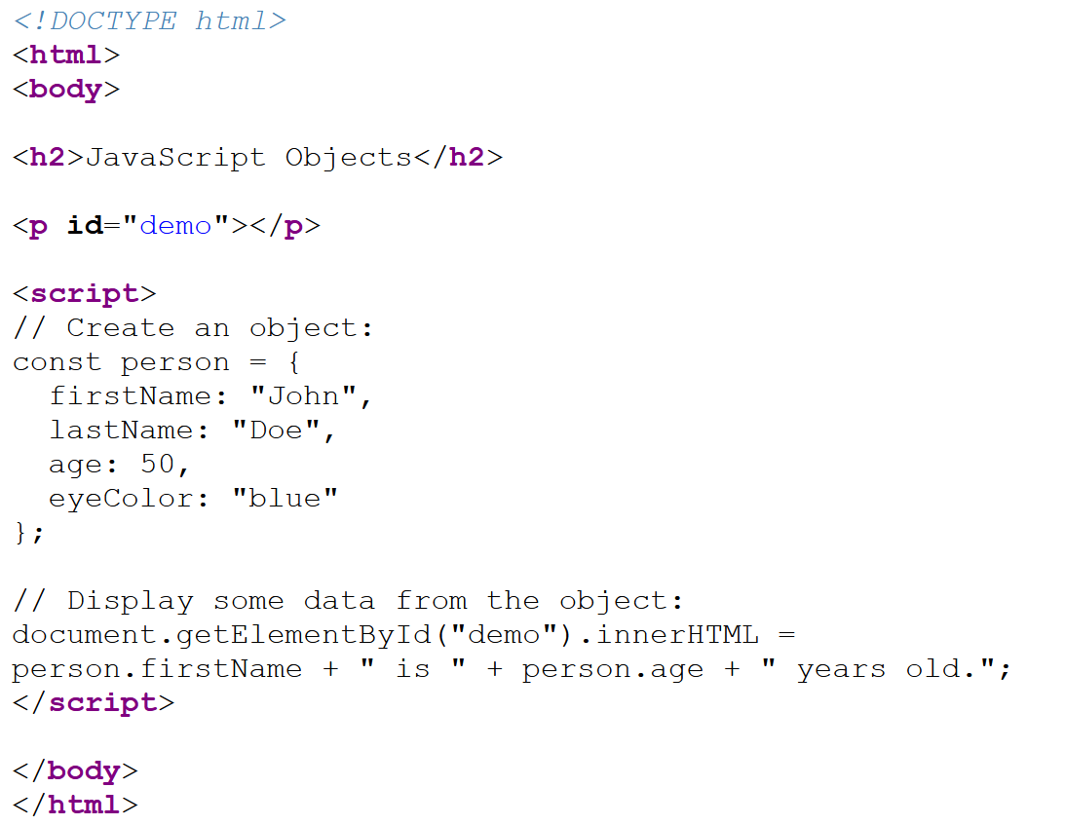

**OUTPUT**

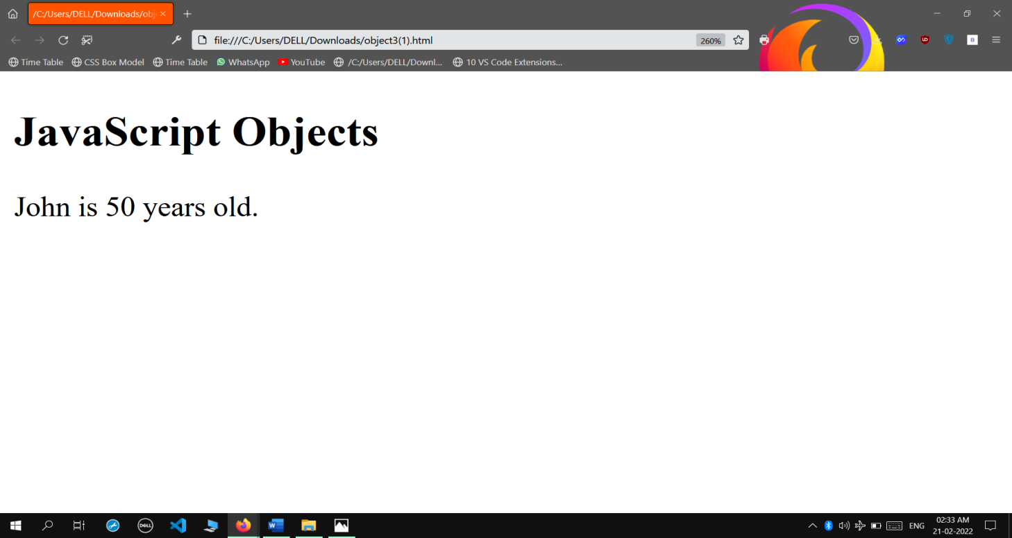

* **Java Script Object 2**

**INPUT**

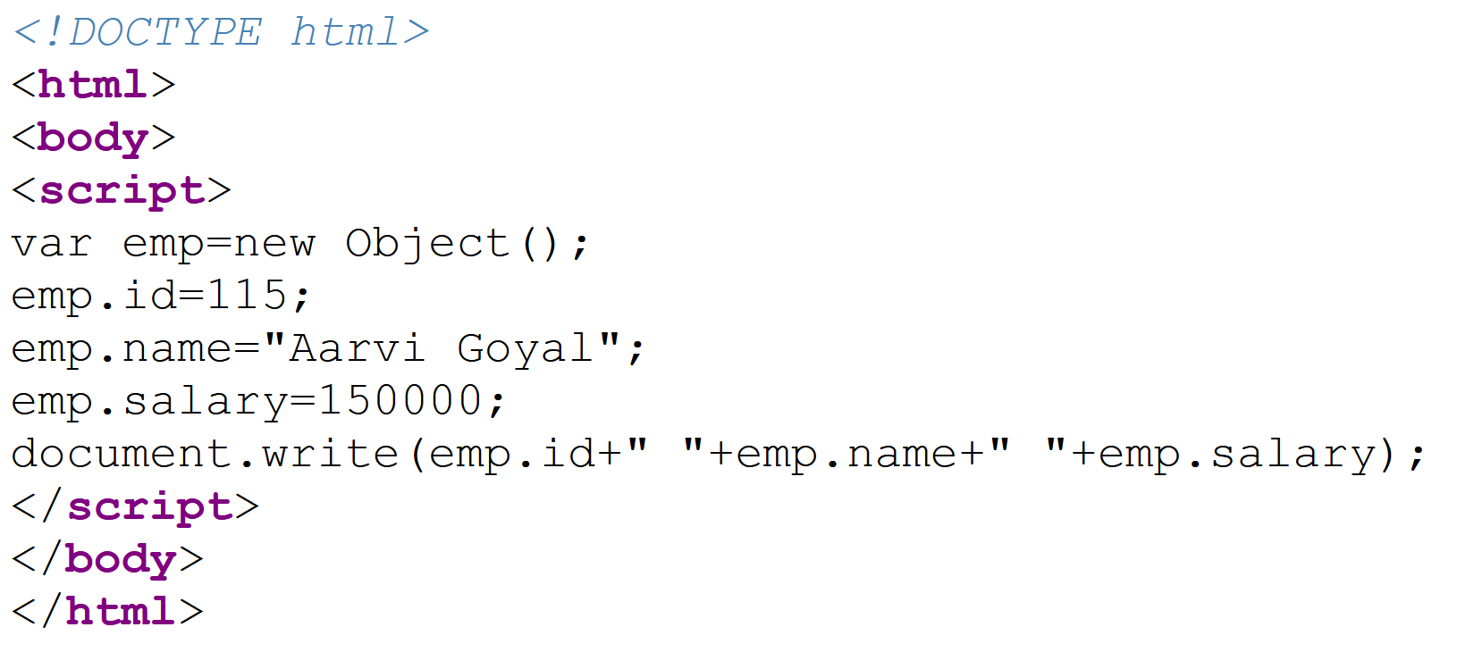

**OUTPUT**

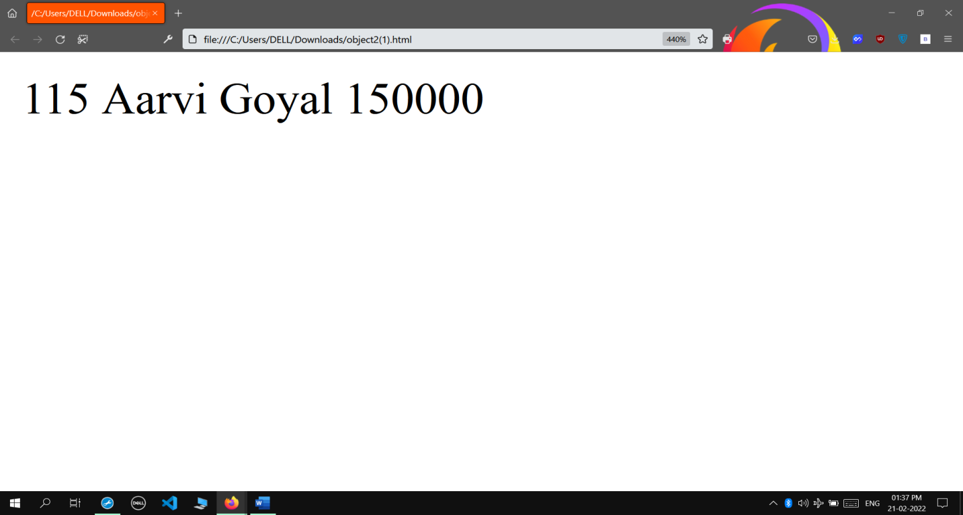

* **Java Script Debugger**

**INPUT**

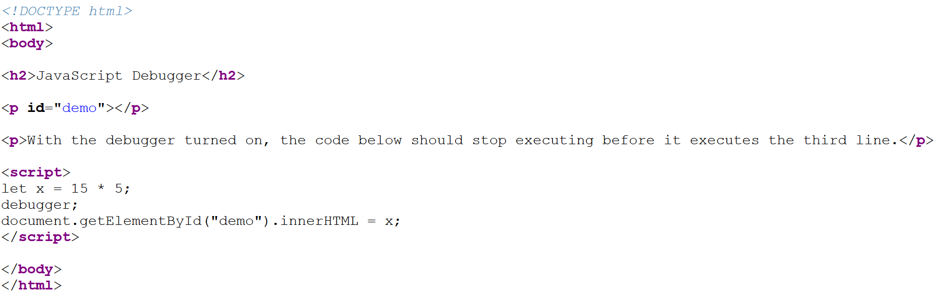

**OUTPUT**

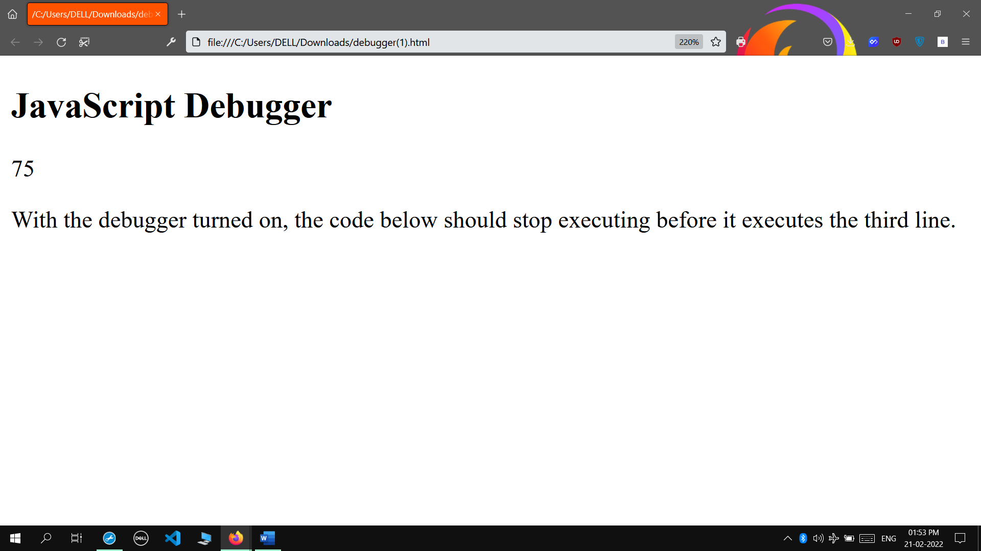

* **Java Script Arithmetic Operators**

**INPUT**

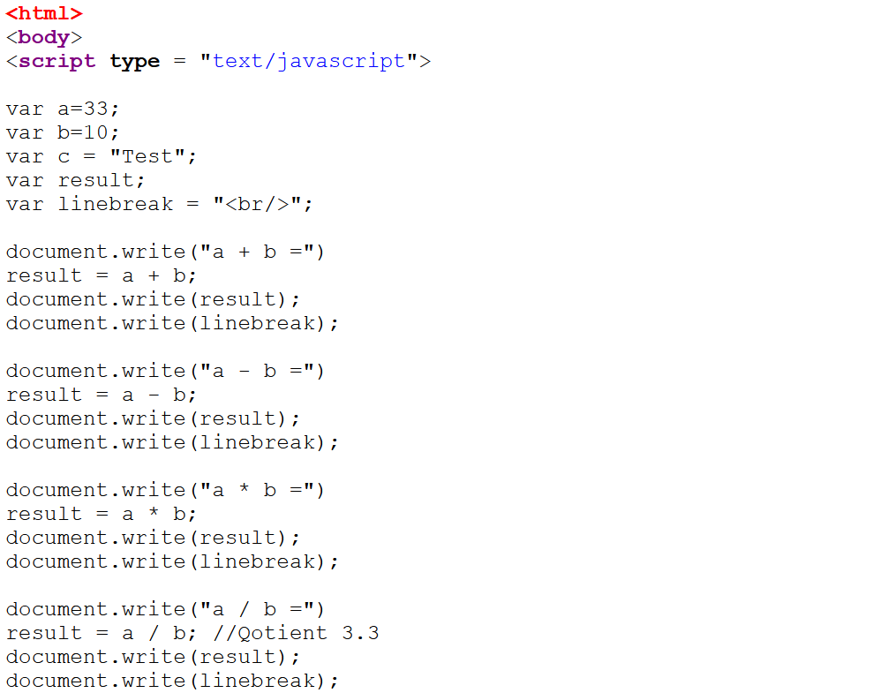

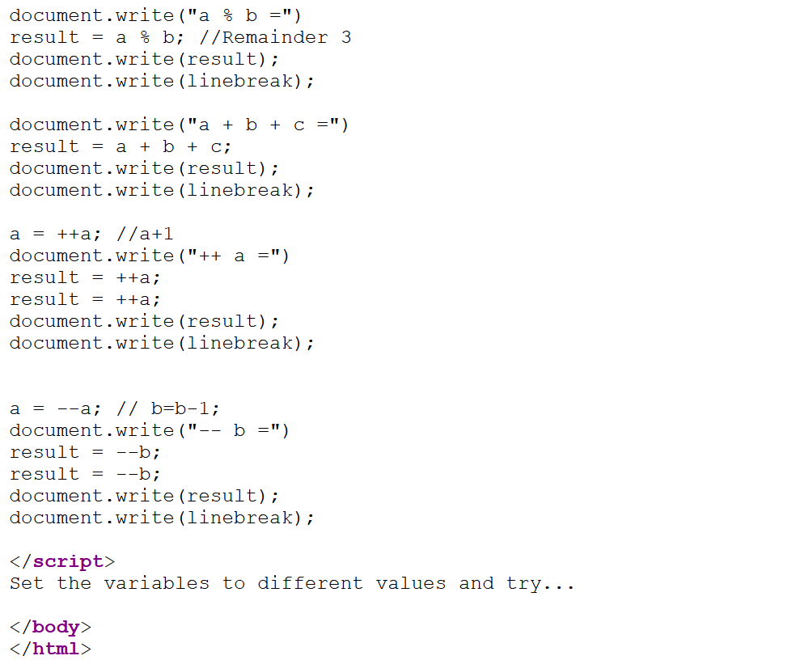

**OUTPUT**

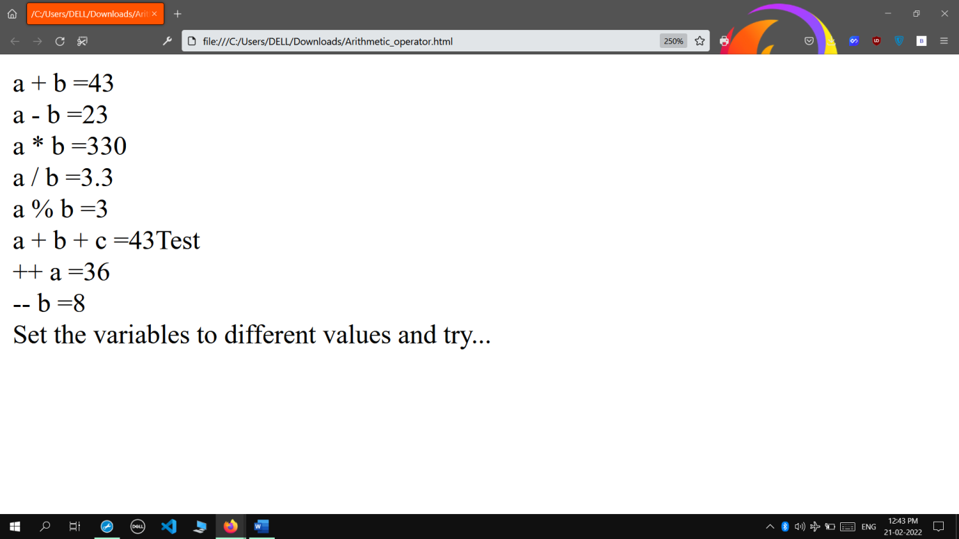

* **Java Script Comparison Operators**

**INPUT**

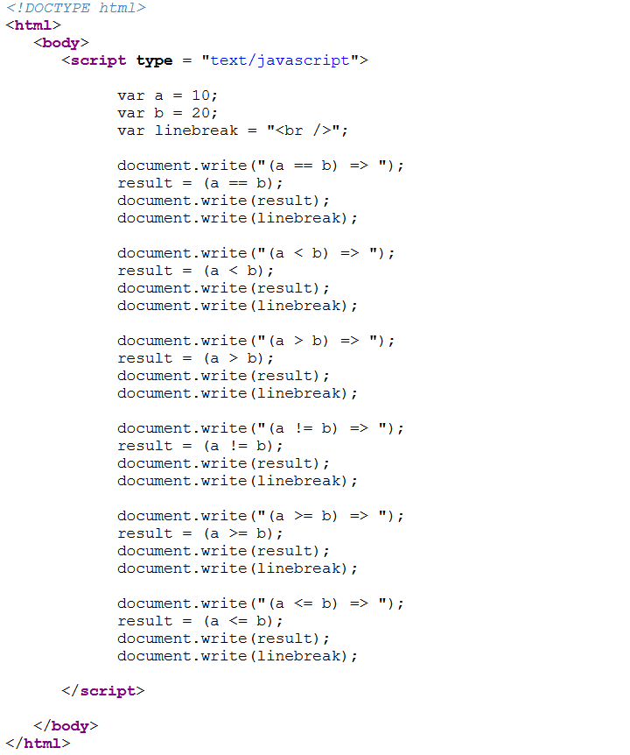

**OUTPUT**

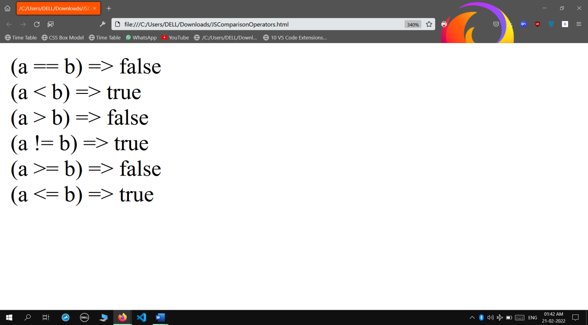

* **Java Script Bitwise Operators**

**INPUT**

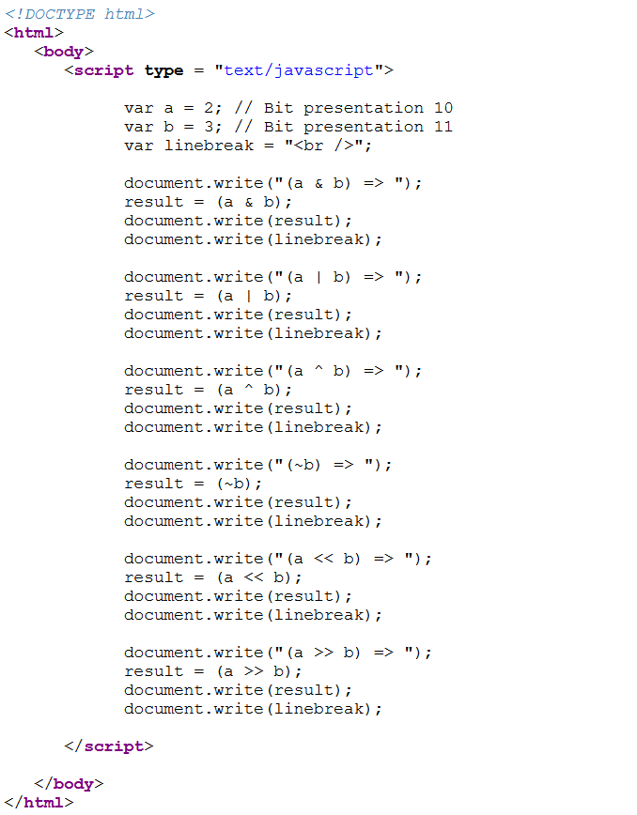

**OUTPUT**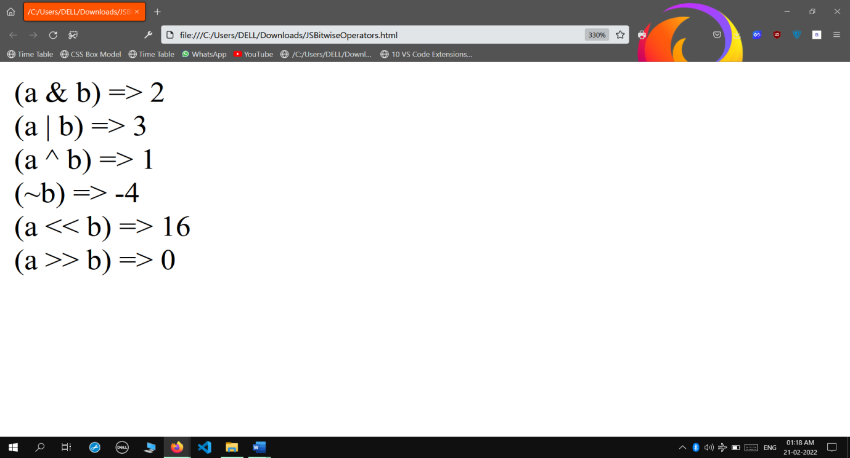

* **Java Script Logical Operators**

**INPUT**

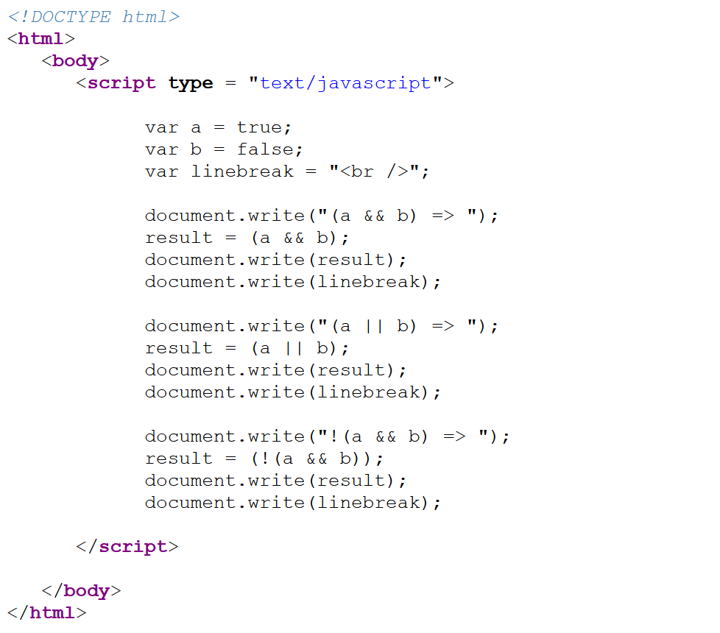

**OUTPUT**

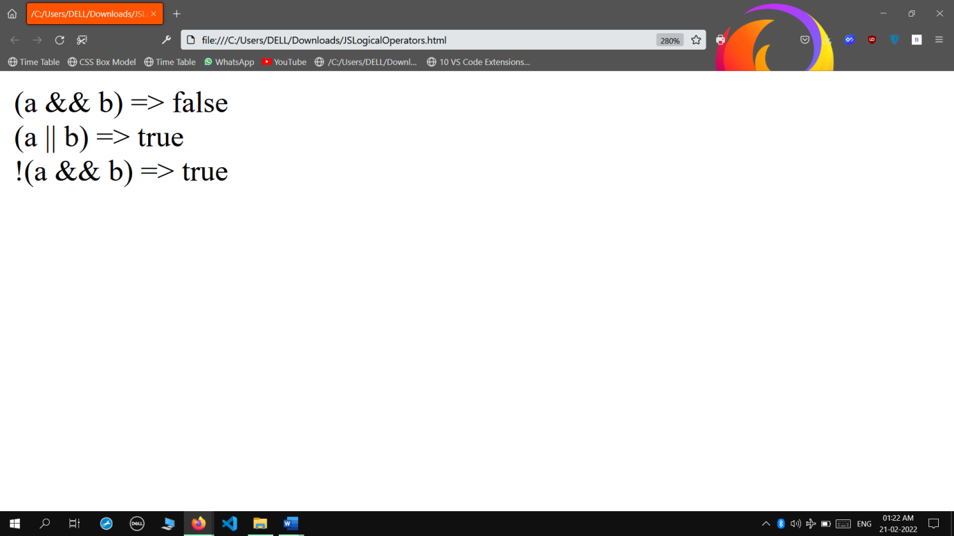

* **Java Script Assignment Operators**

**INPUT**

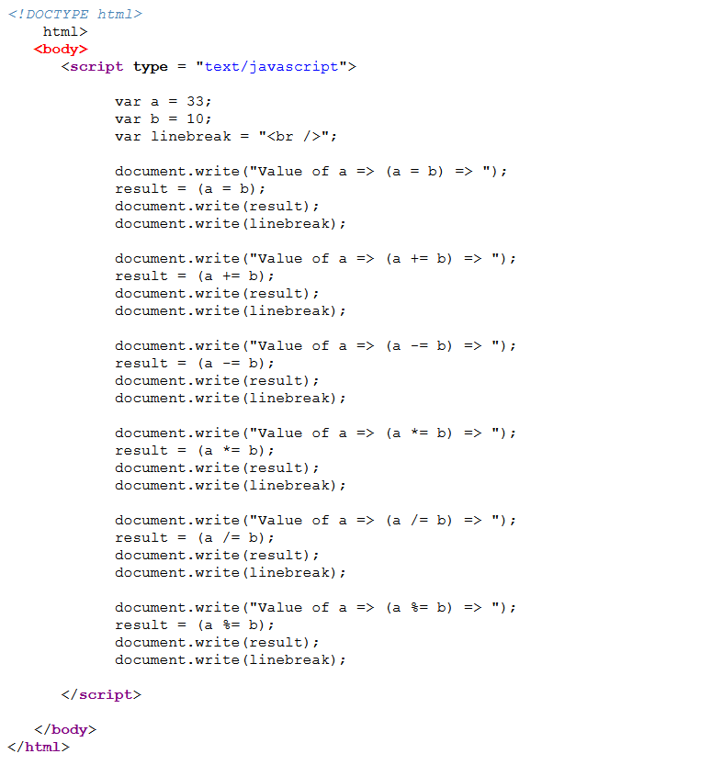

**OUTPUT**

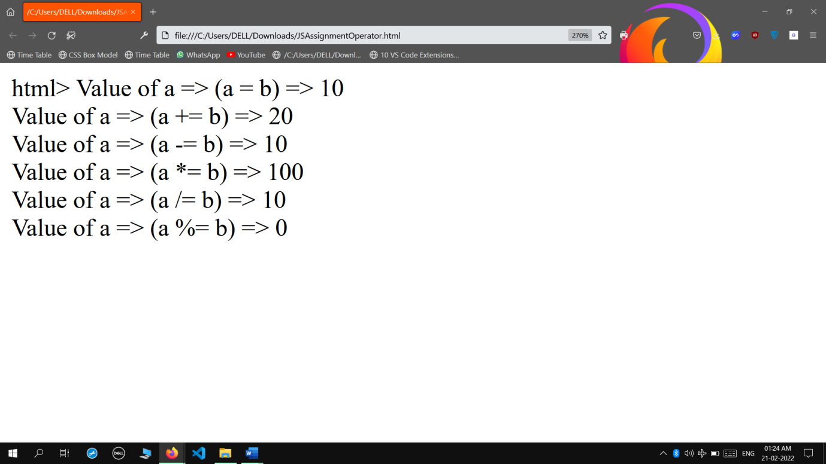

* **Java Script Array Objects**

**INPUT**

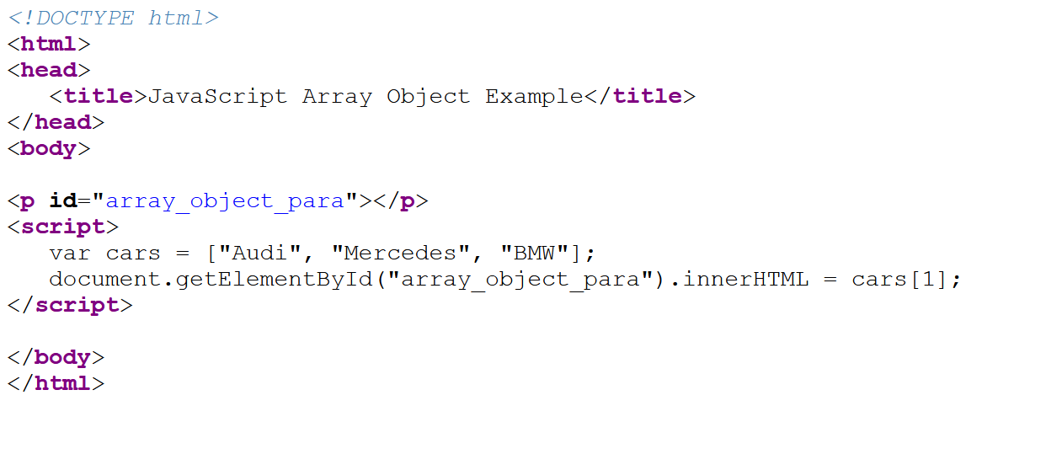

**OUTPUT**

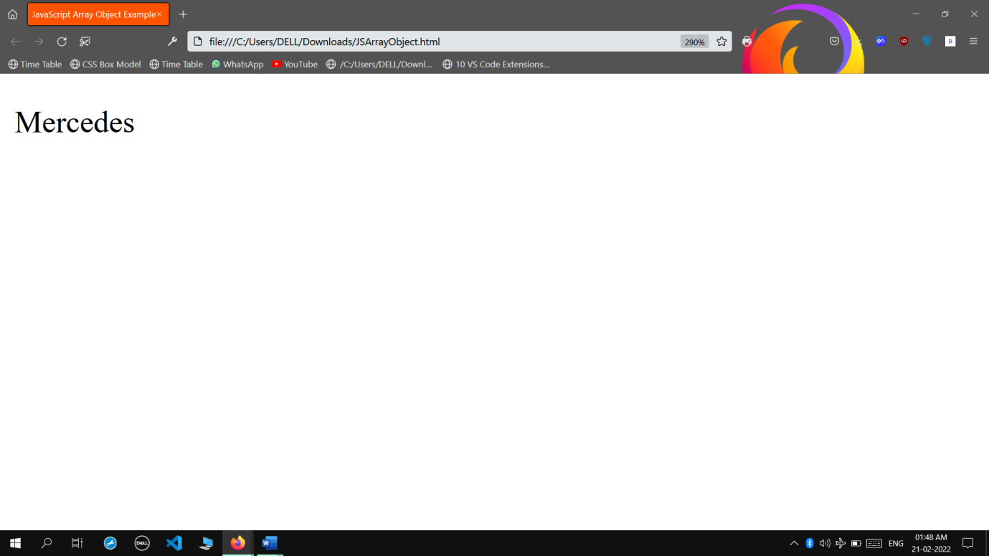

* **Java Script Assignment**

**INPUT**

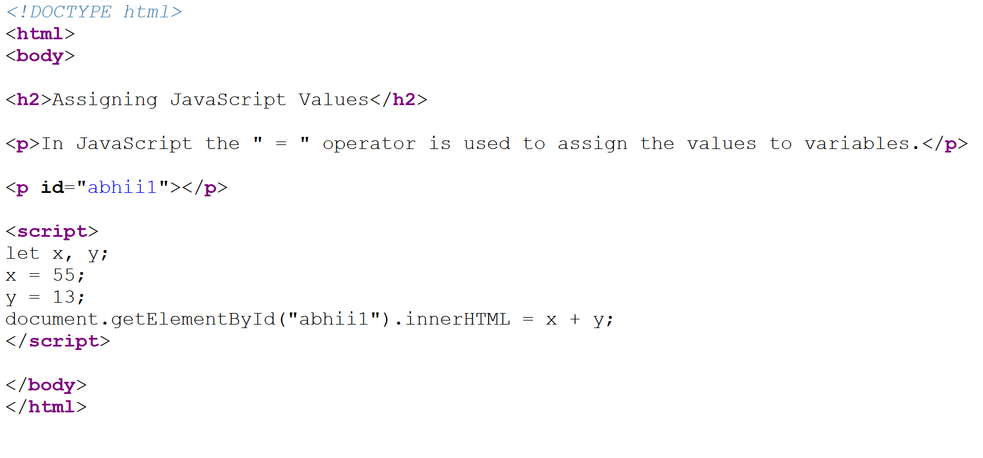

**OUTPUT**

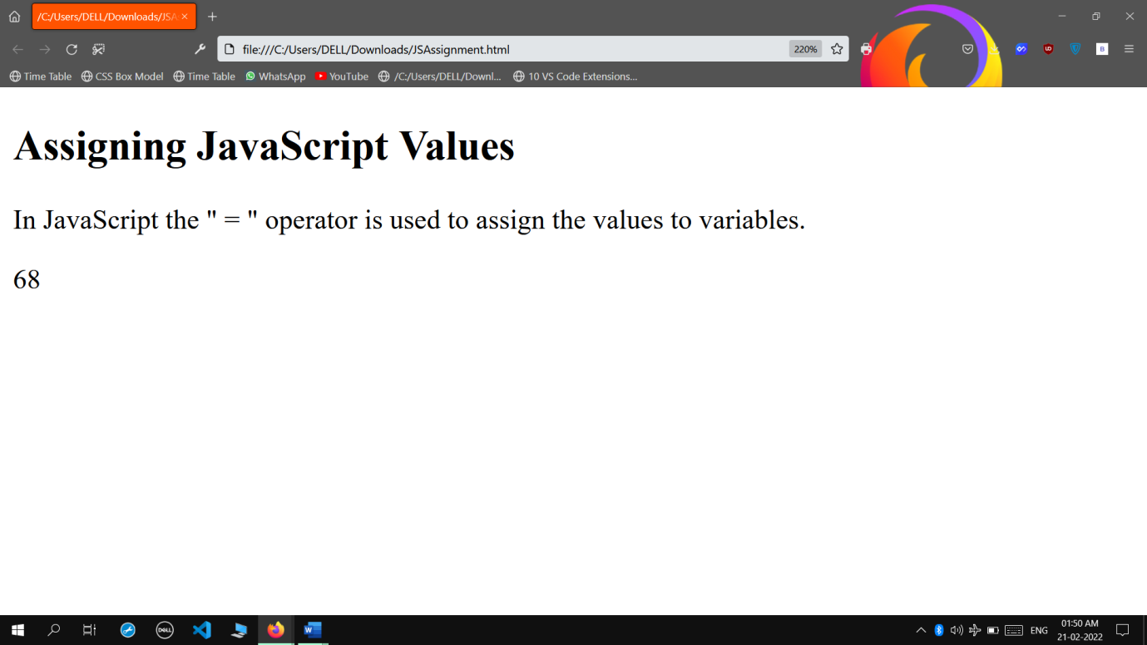

* **Java Script Boolean Object**

**INPUT**

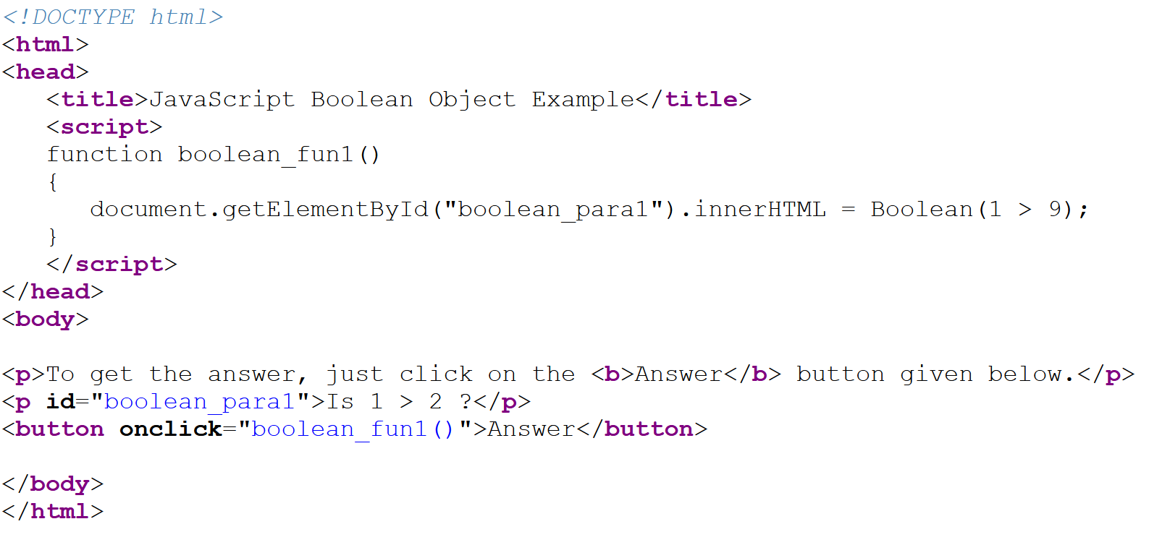

**OUTPUT**

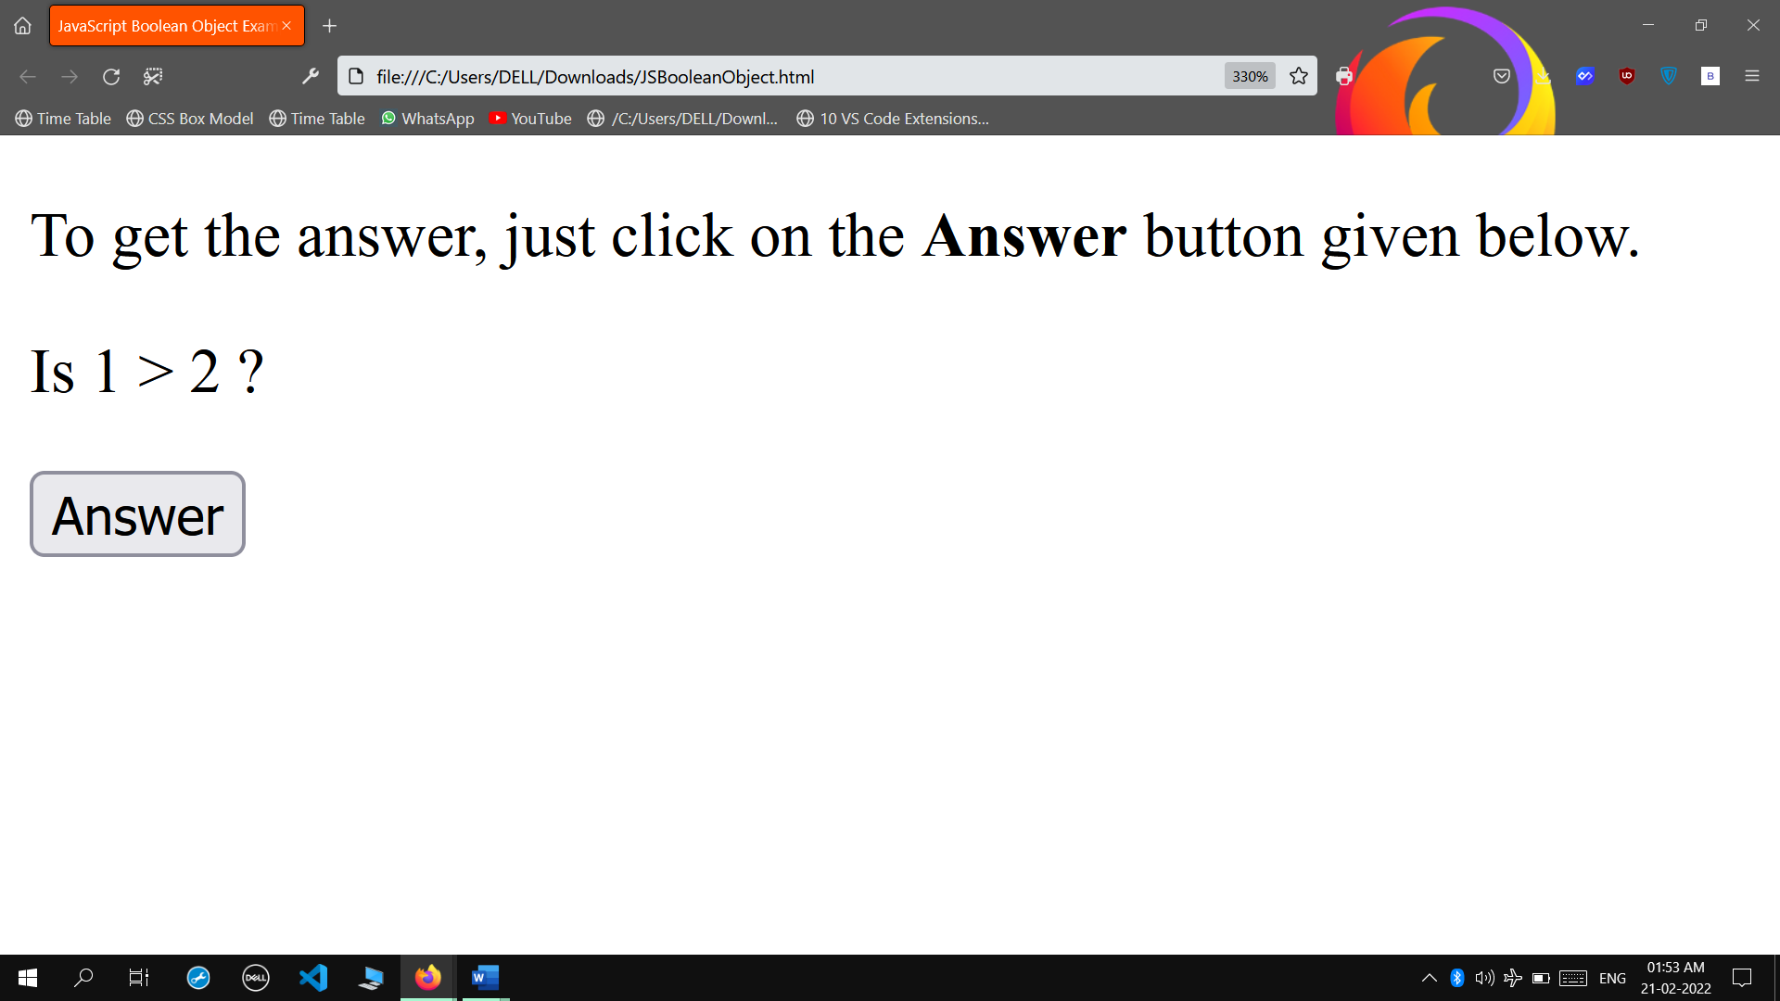

**When Answer Button is Clicked:**

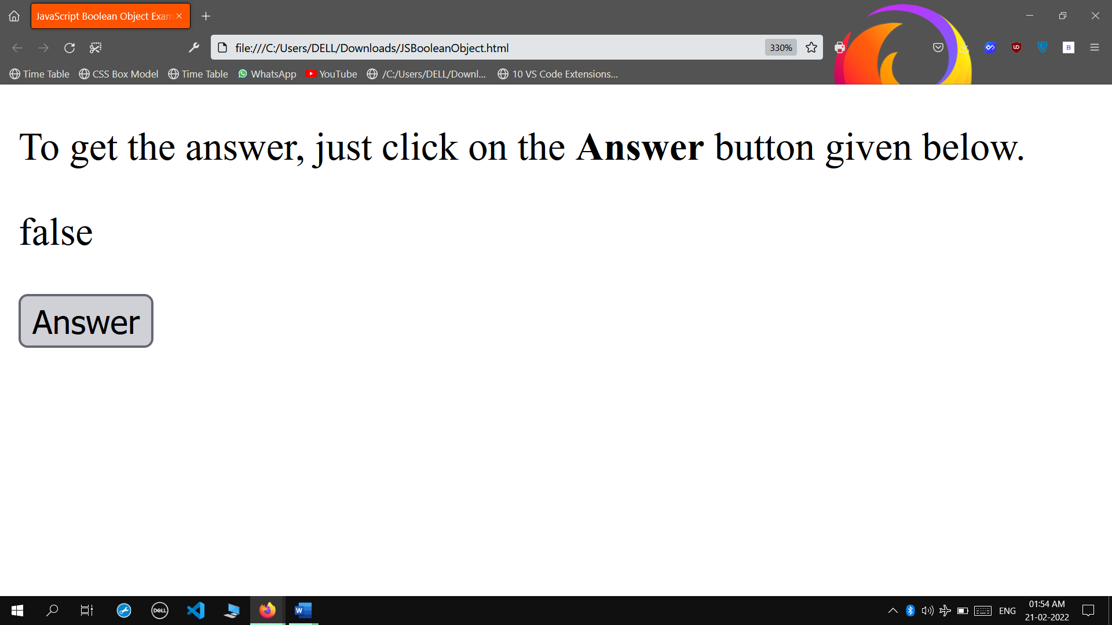

* **Java Script is Case Sensitive**

**INPUT**

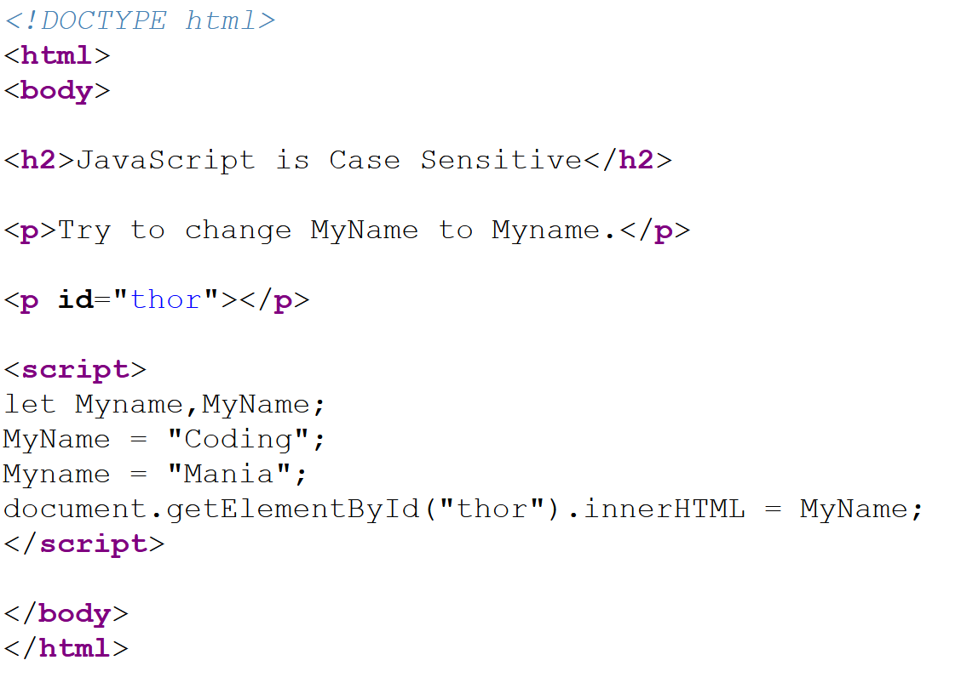

**OUTPUT**

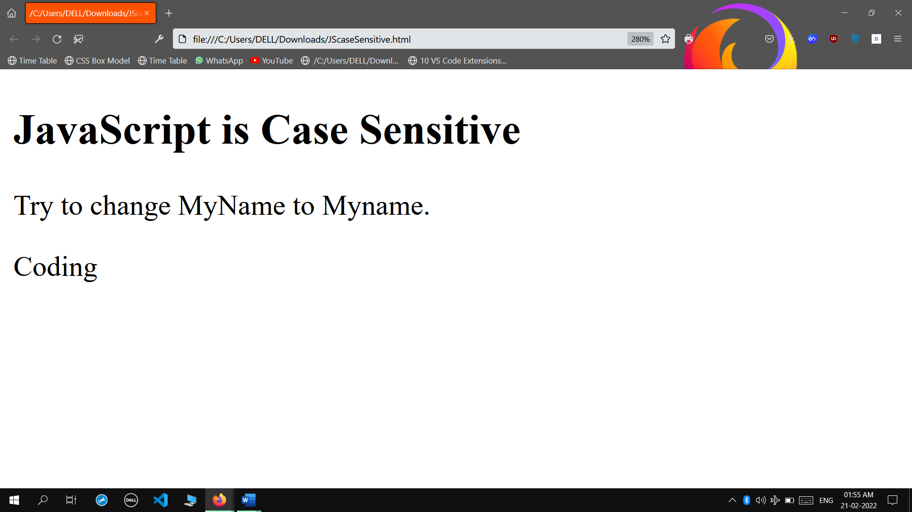

* **Java Script Date & Time**

**INPUT**

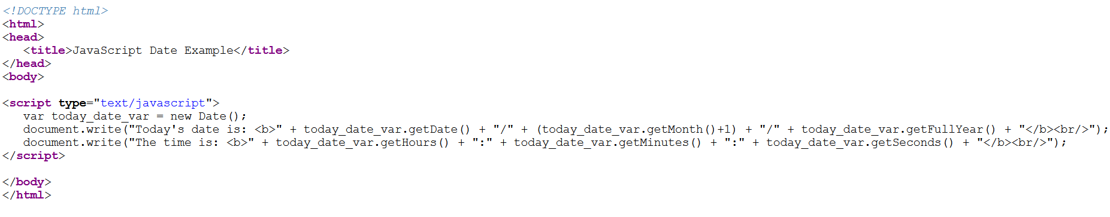

**OUTPUT**

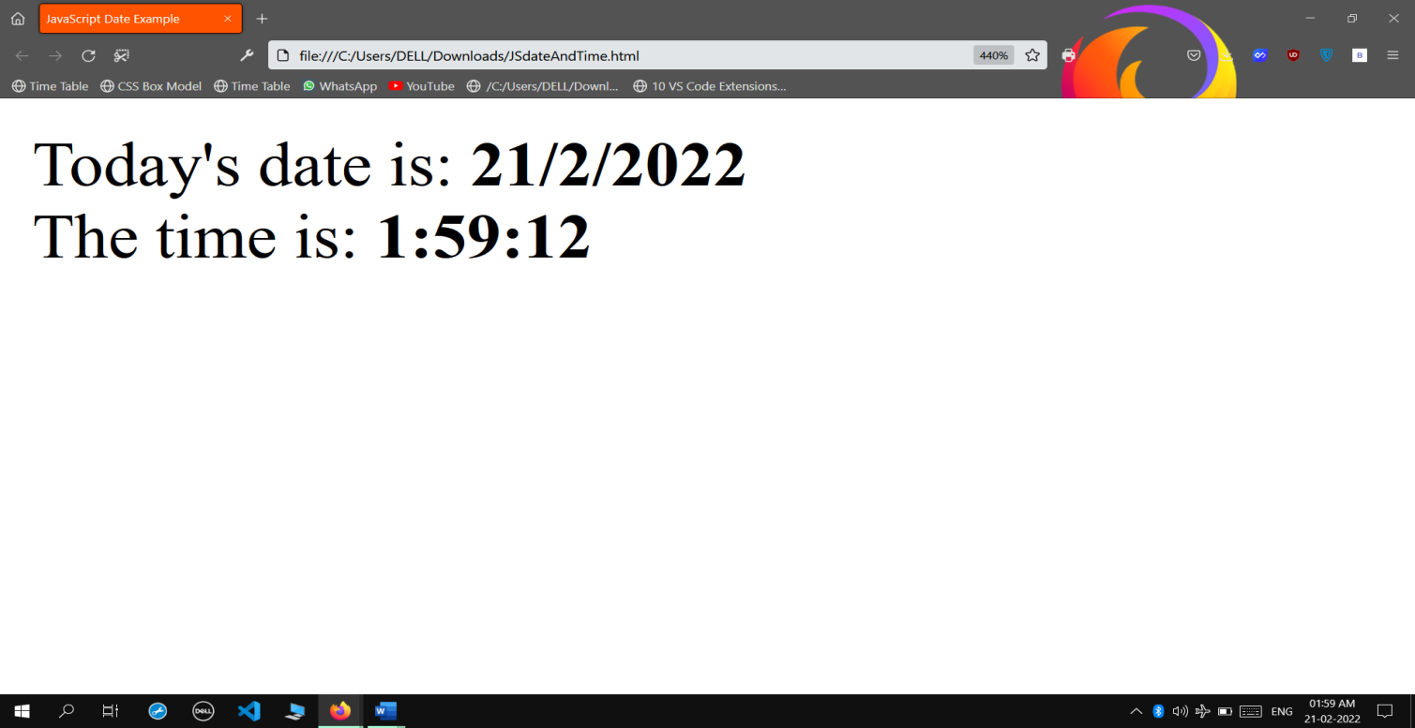

* **Java Script Dialogue Box**

**INPUT**

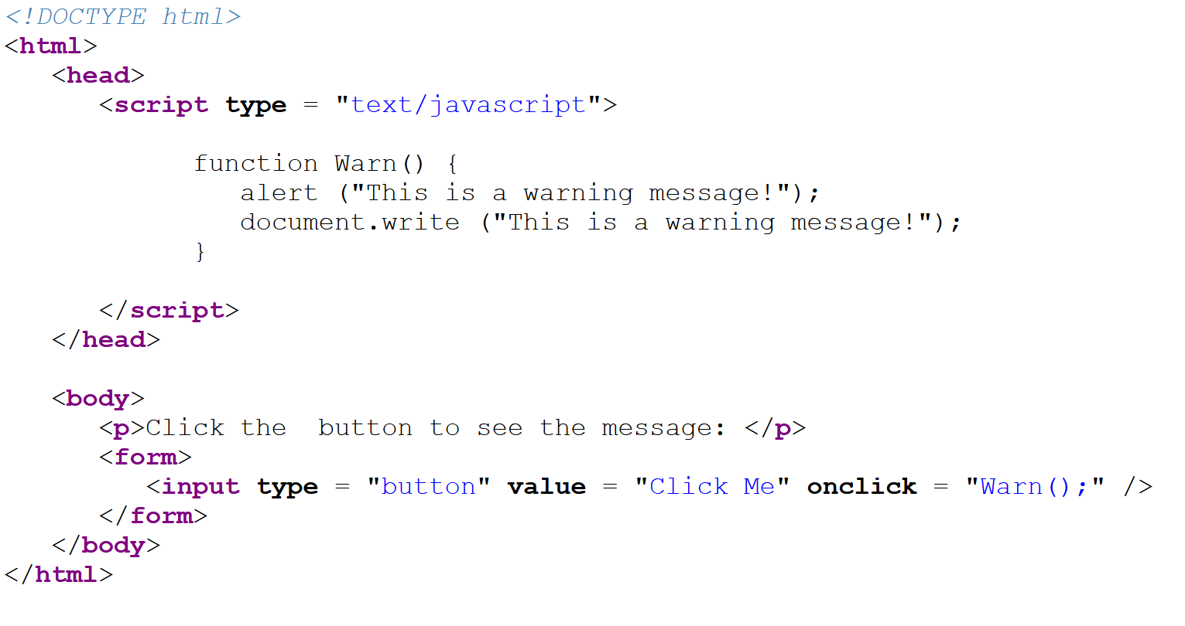

**OUTPUT**

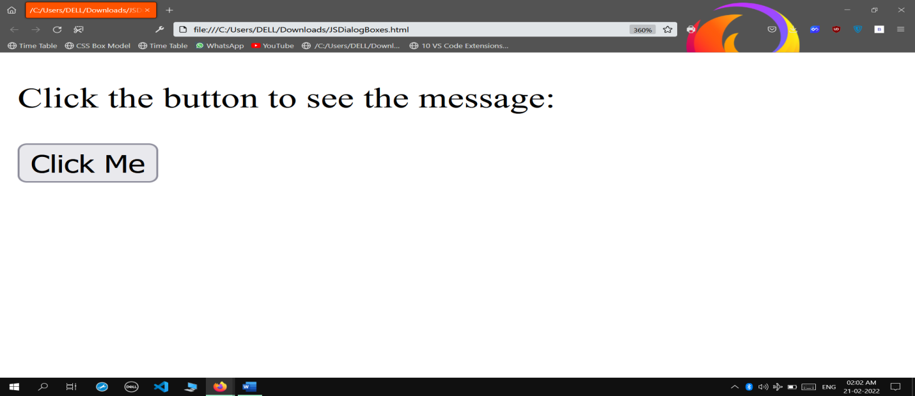

**When Button is clicked:**

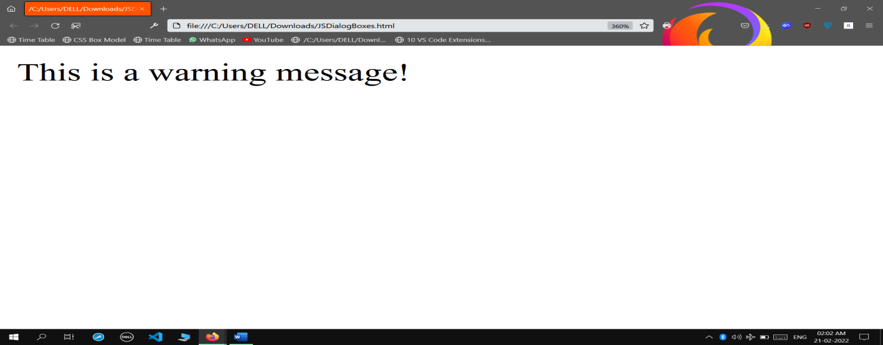

* **Java Script Keyword**

**INPUT**

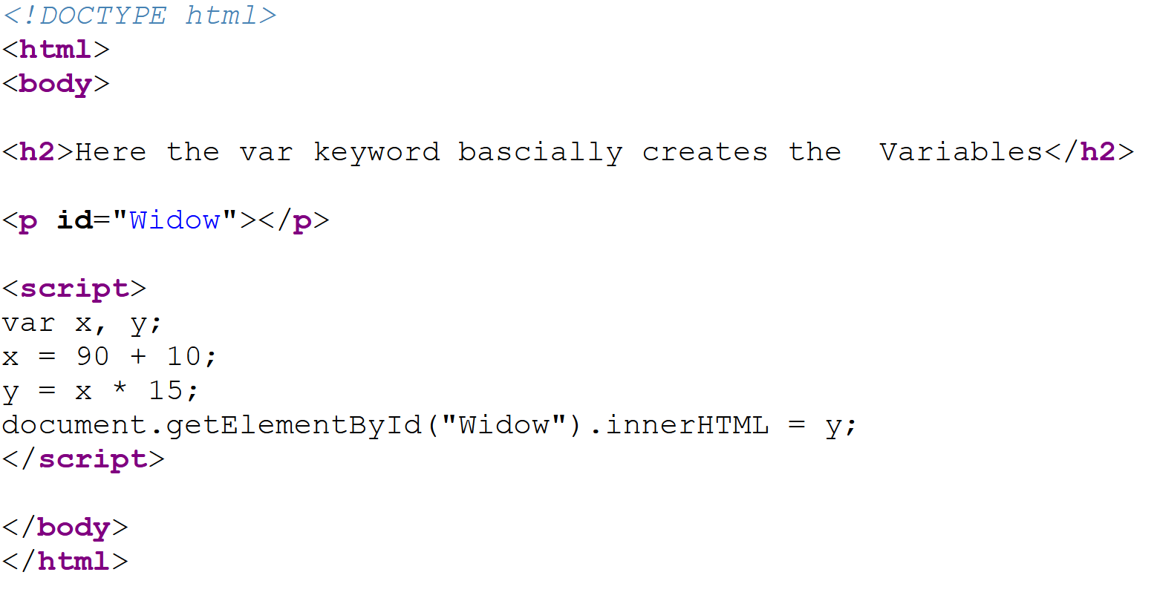

**OUTPUT**

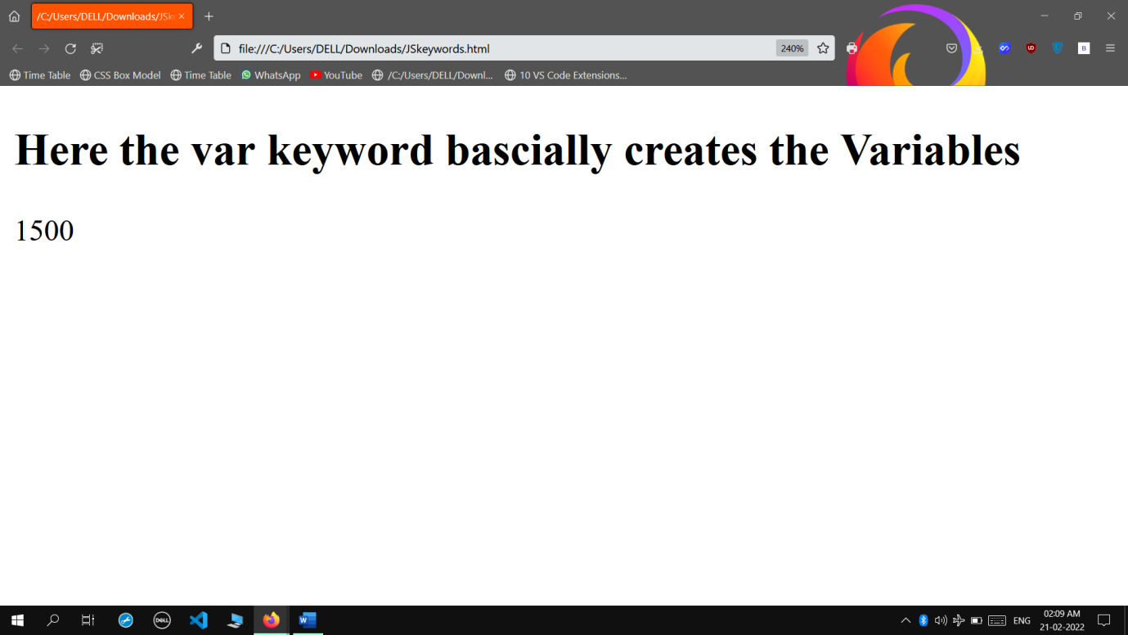

* **Java Script Local & Global Values**

**INPUT**

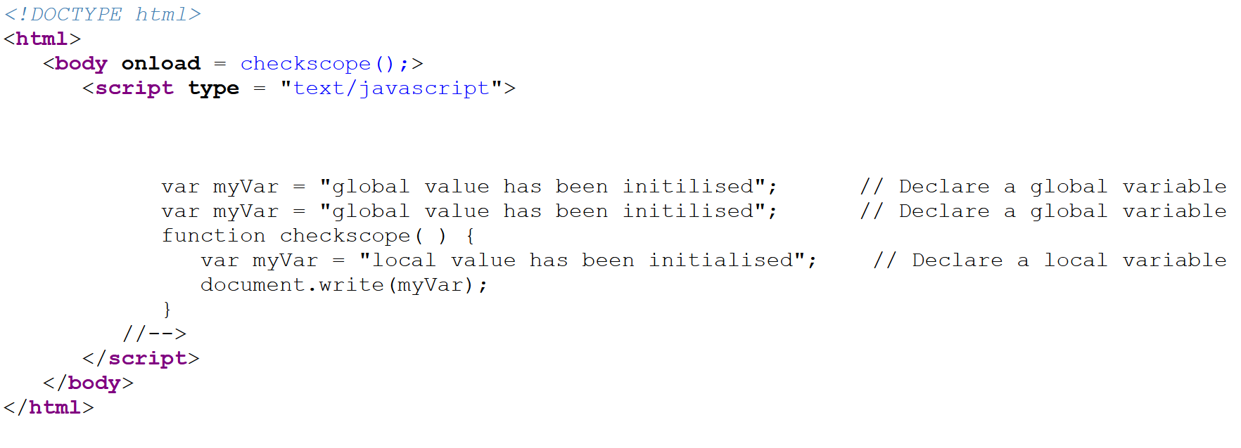

**OUTPUT**

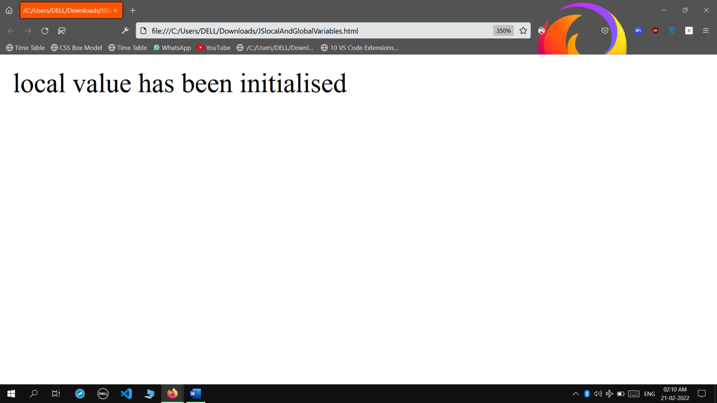

* **Java Script Math Object**

**INPUT**

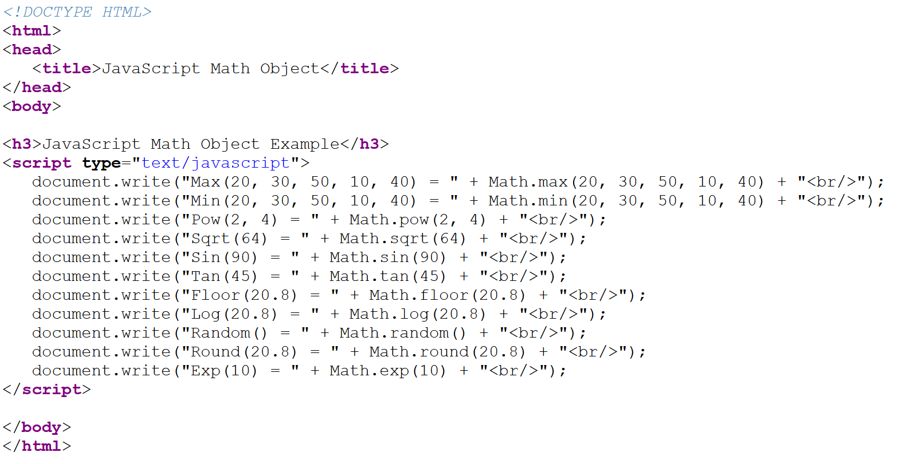

**OUTPUT**

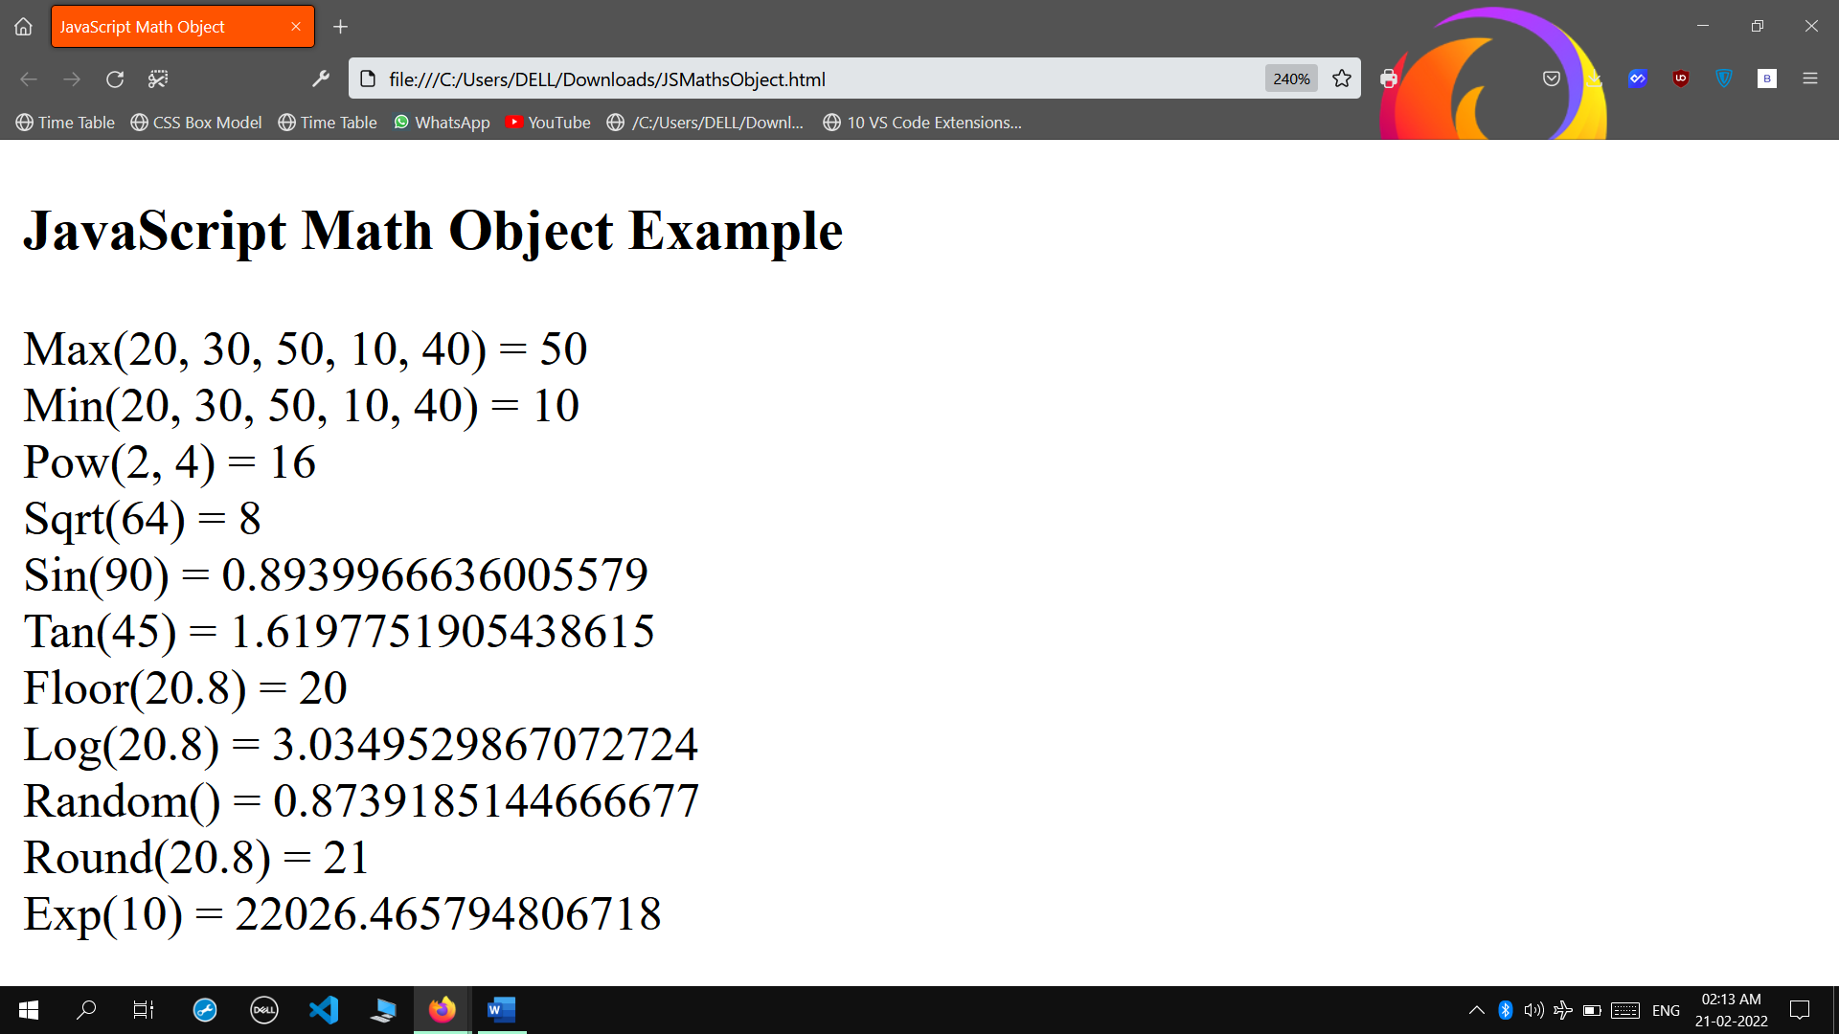

* **Java Script Function**

**INPUT**

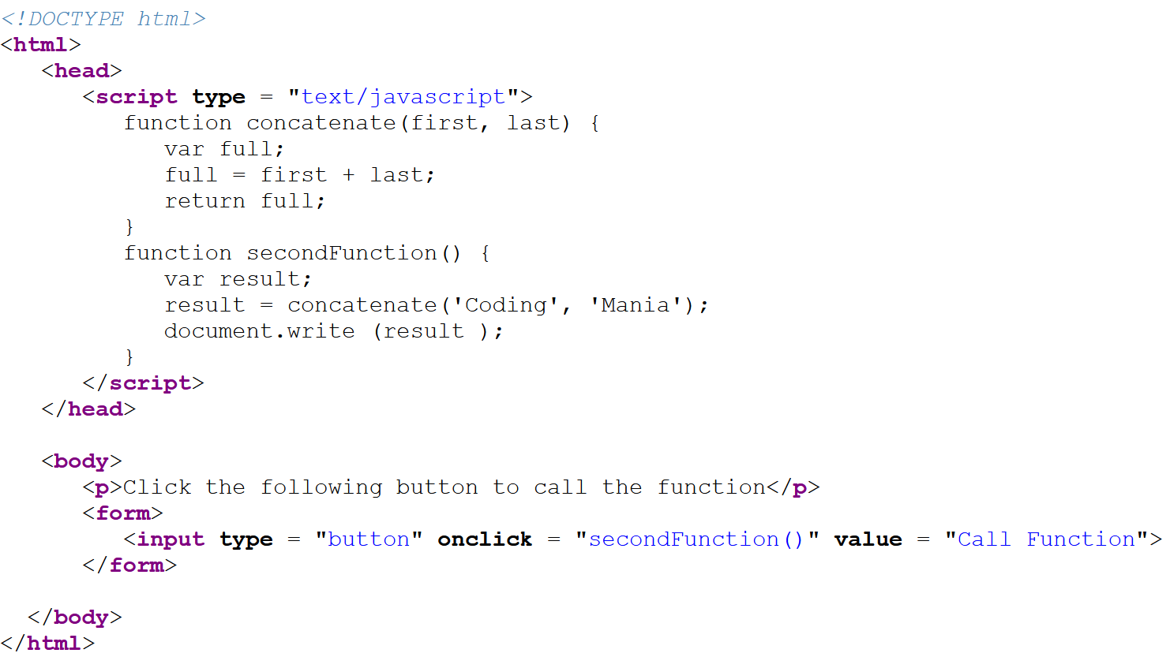

**OUTPUT**

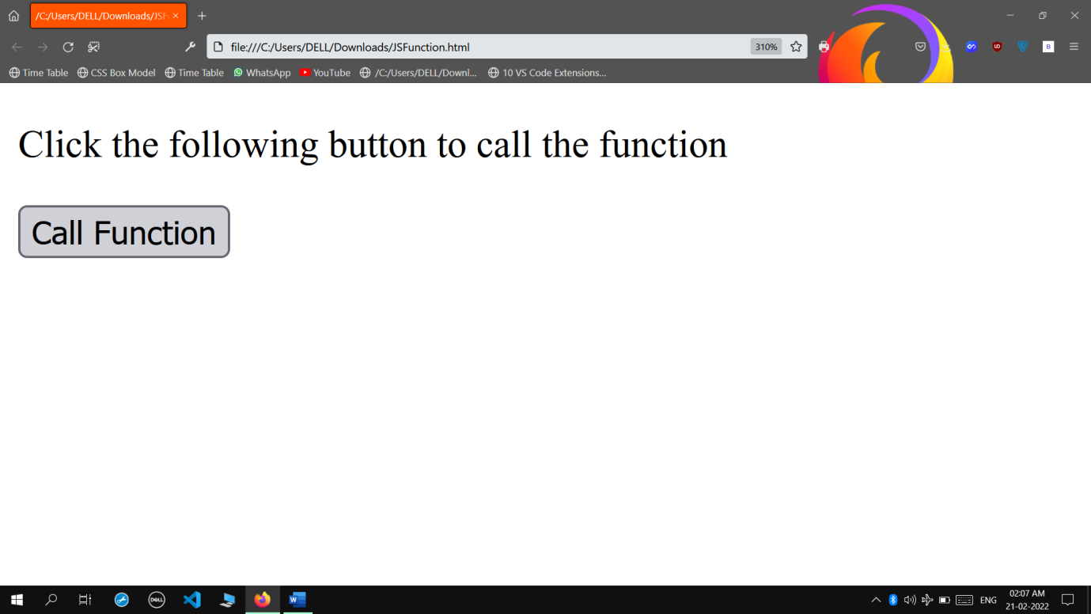

* **Java Script Function 1**

**INPUT**

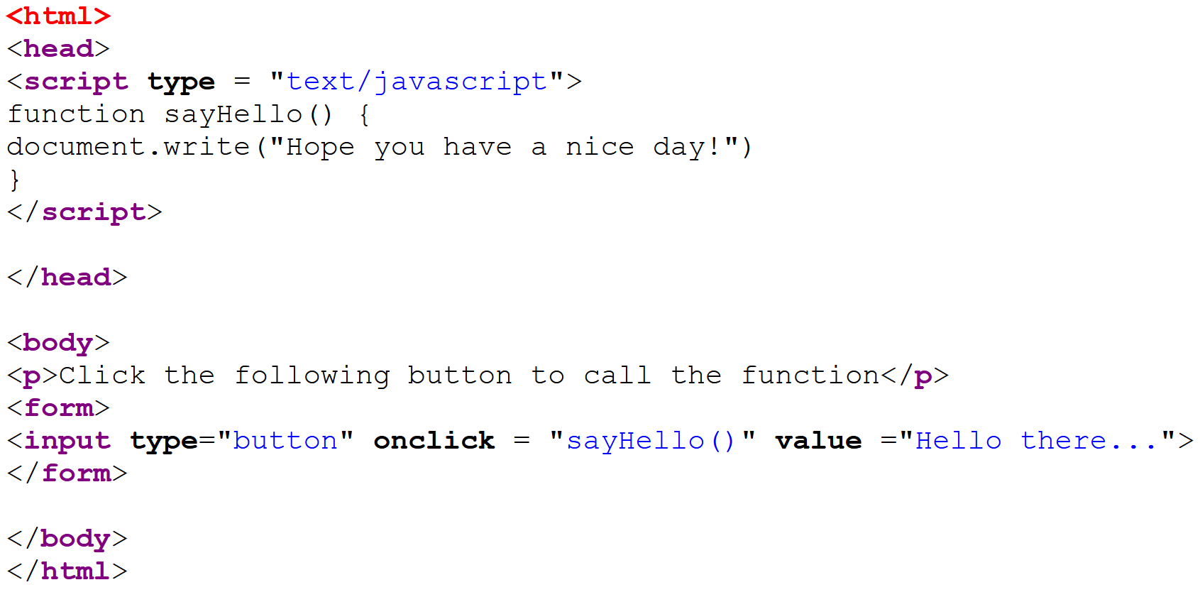

**OUTPUT**

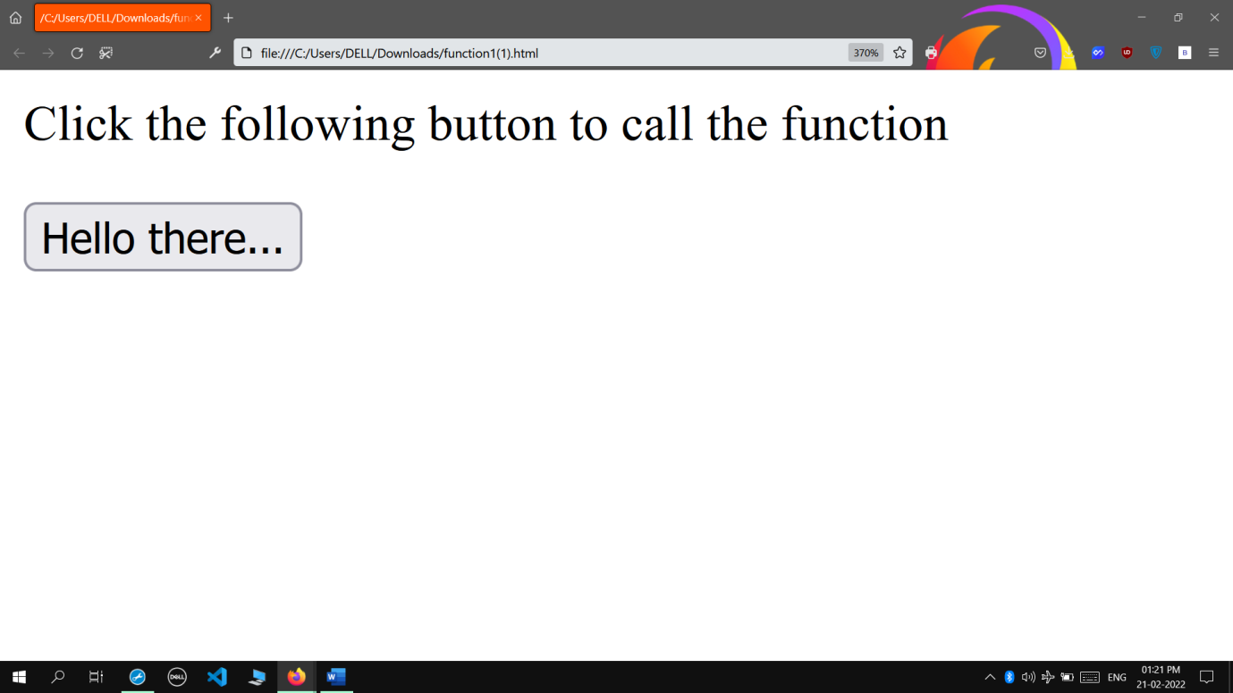

**When button is clicked:**

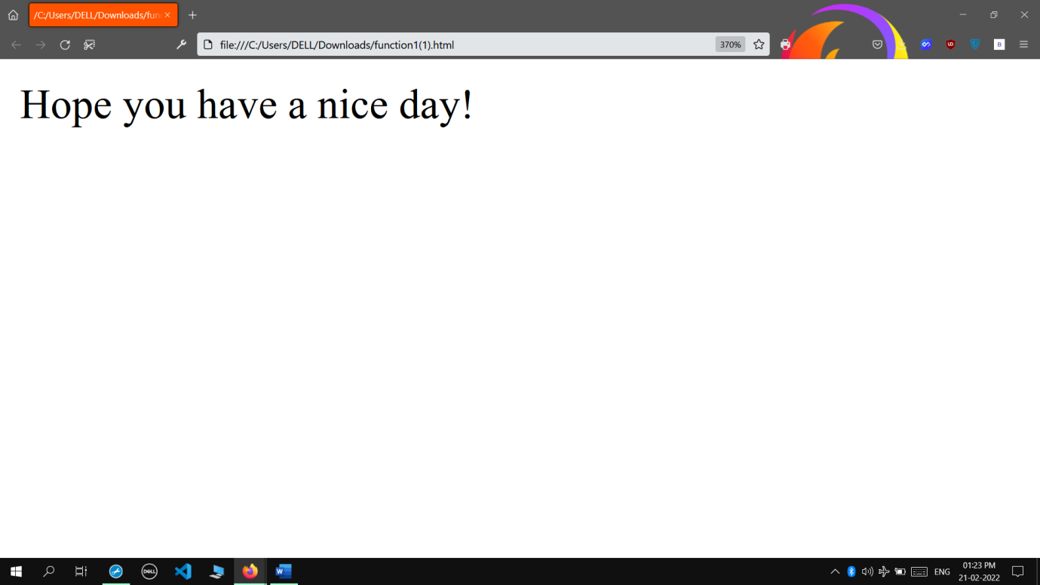

* **Java Script Function 2**

**INPUT**

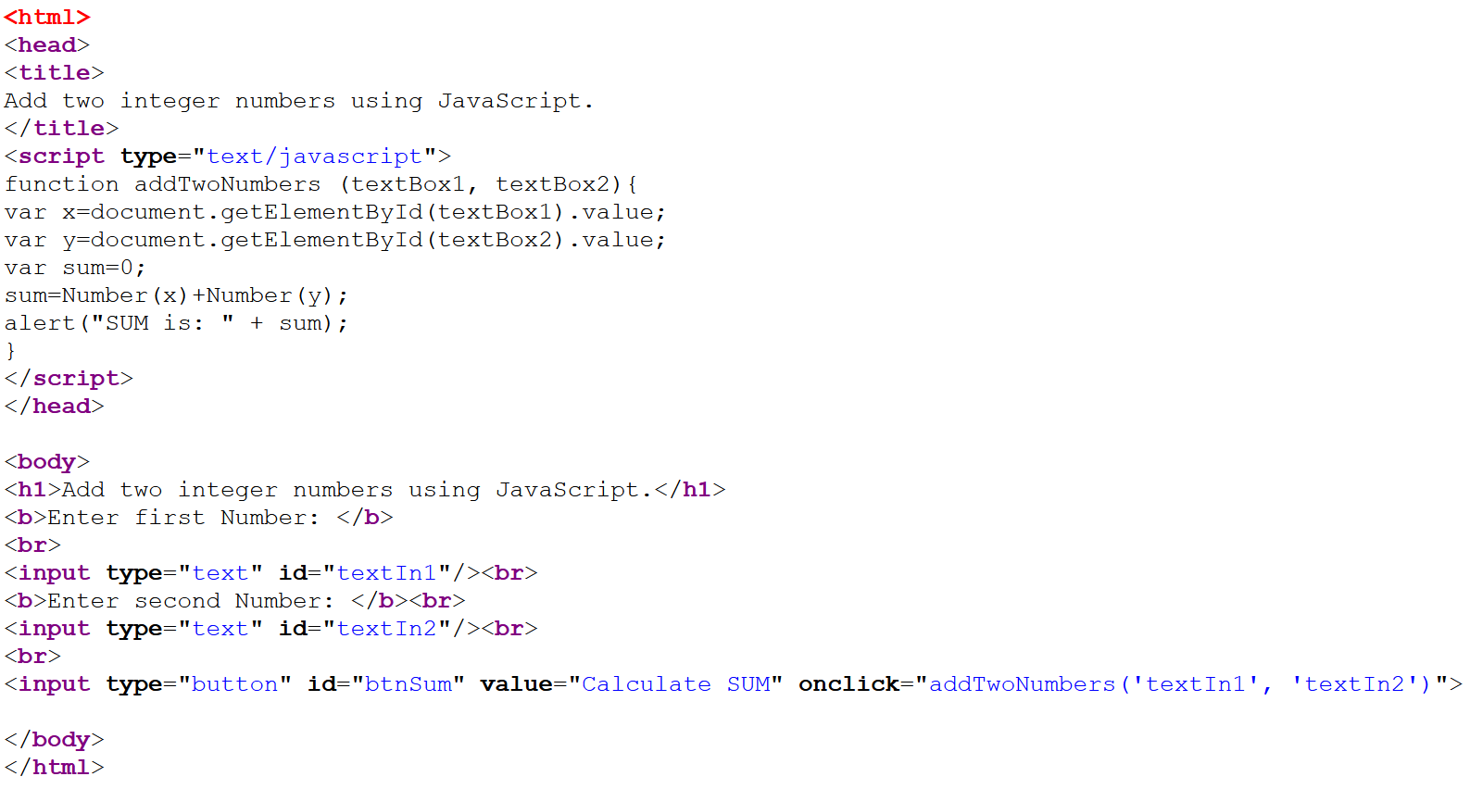

**OUTPUT**

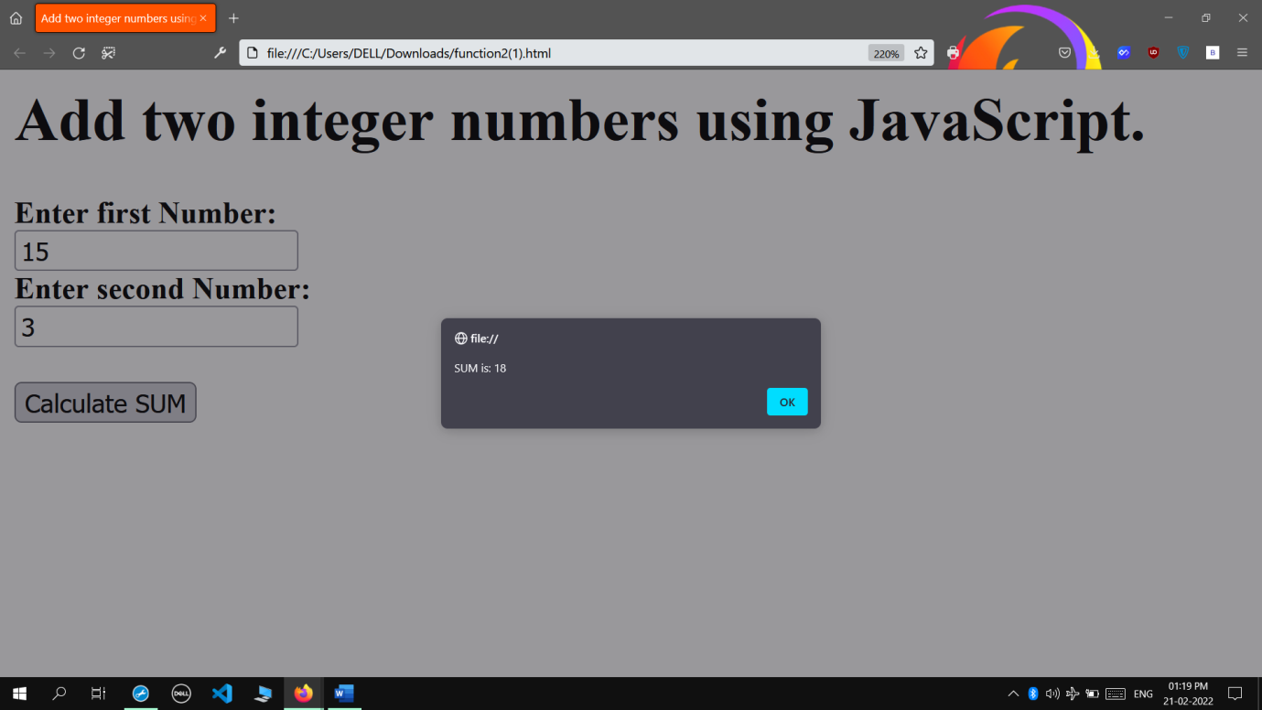

* **Java Script Function 3**

**INPUT**

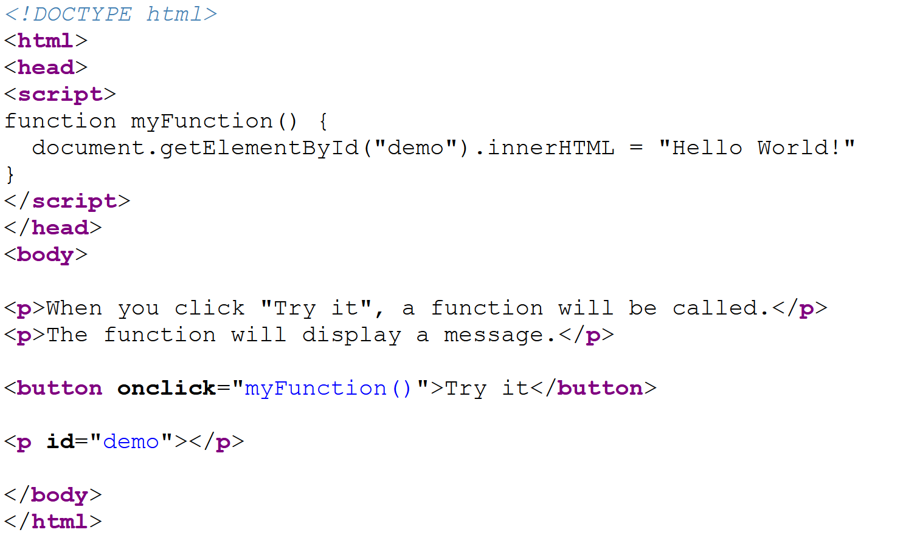

**OUTPUT**

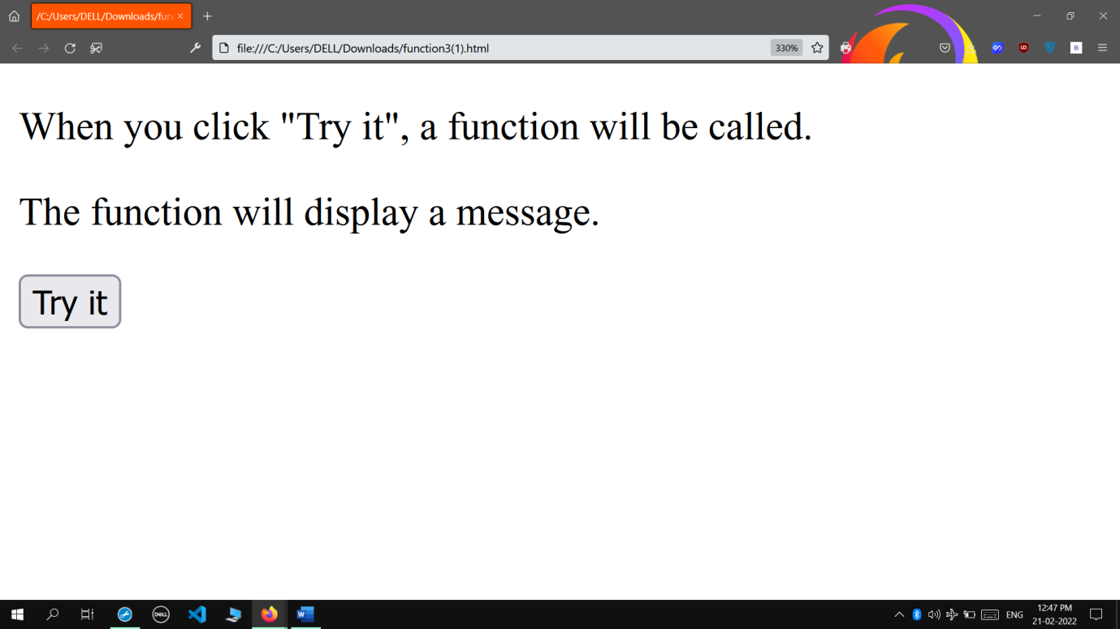

**When Try It is clicked:**

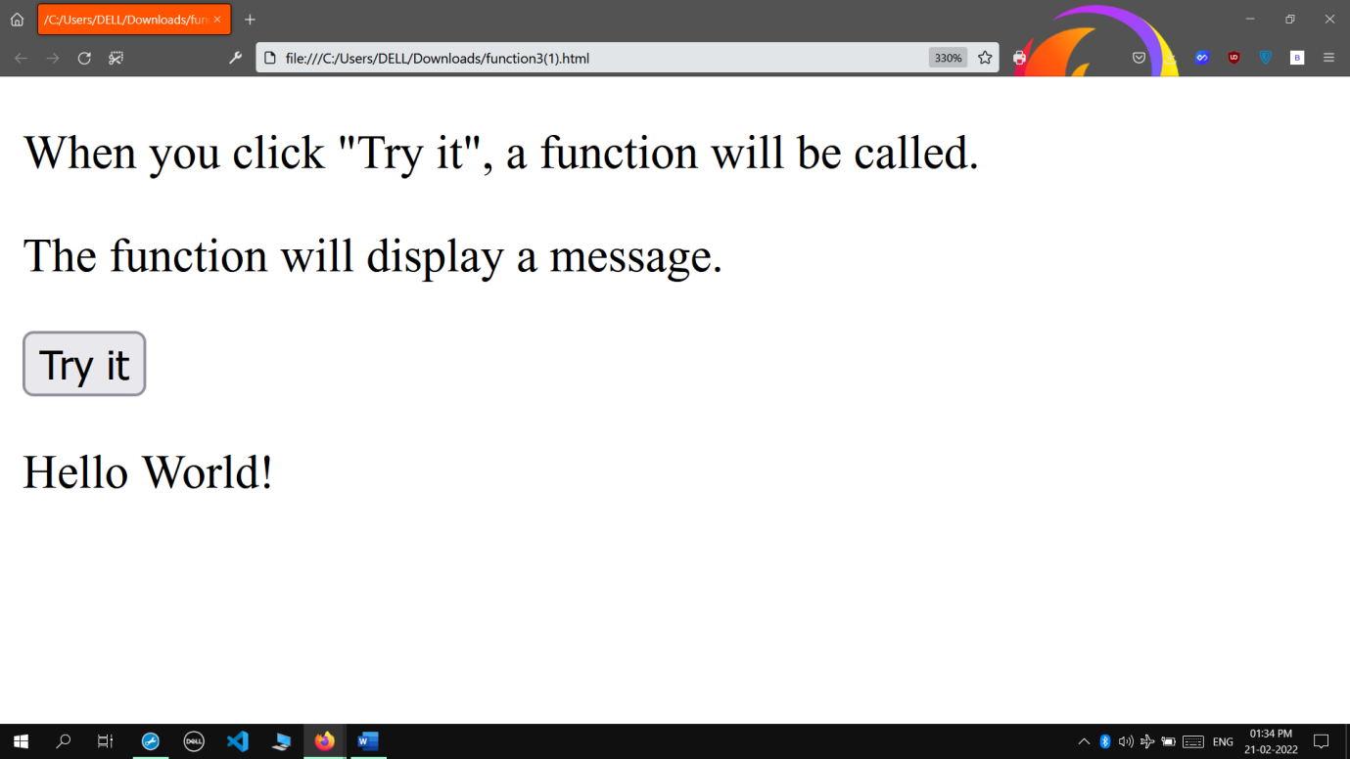

* **Java Script Function 4**

**INPUT**

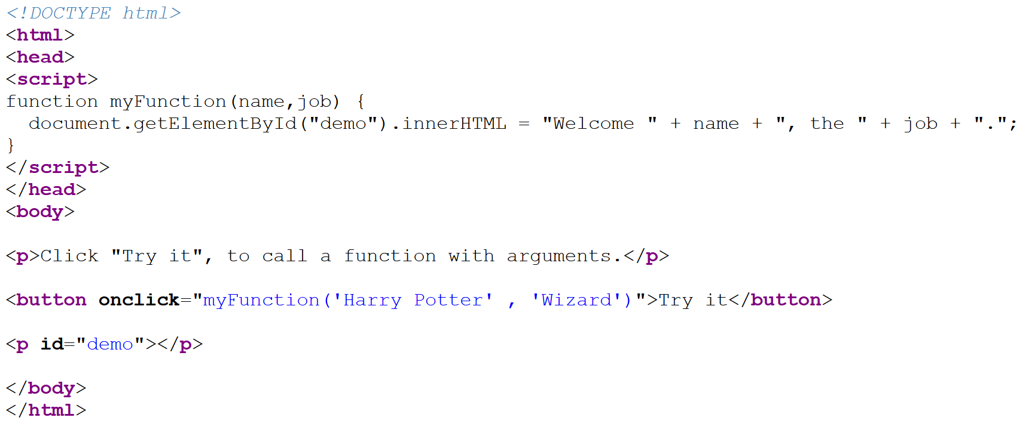

**OUTPUT**

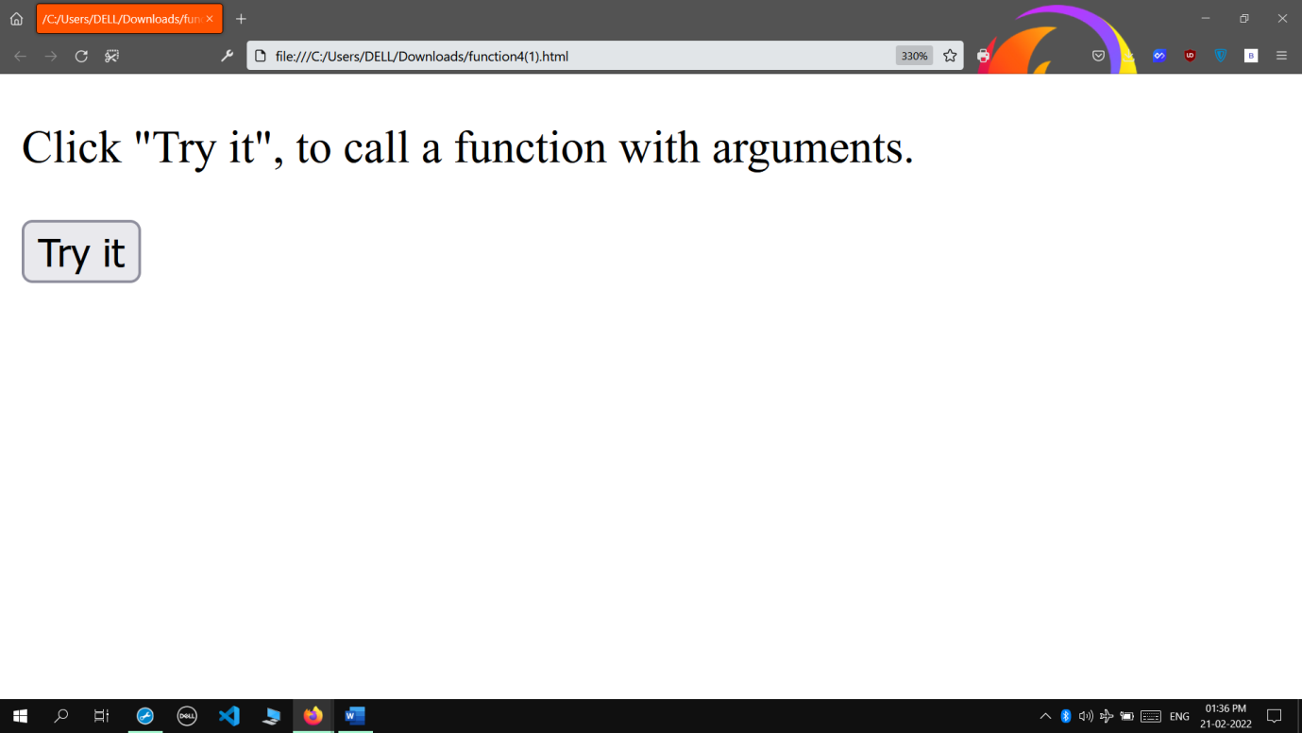

**When Try It is clicked:**

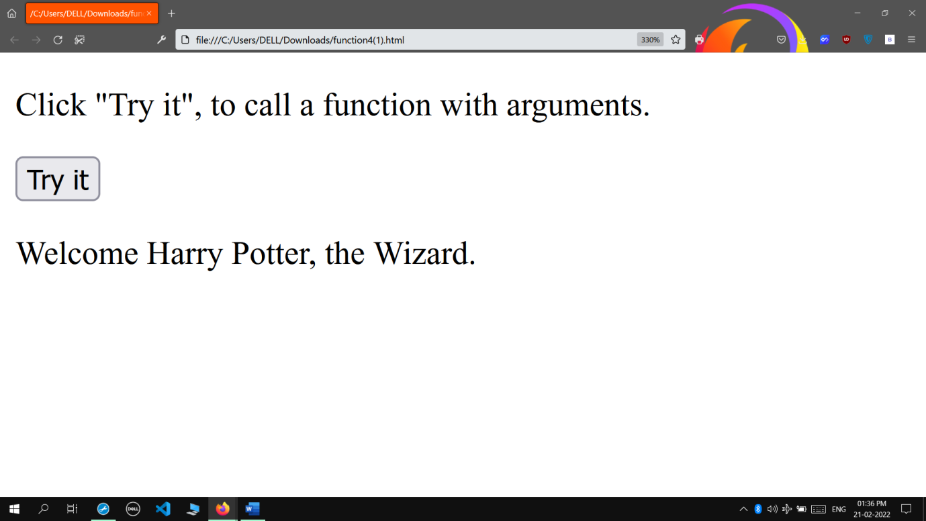

* **Java Script Function With Parameters**

**INPUT**

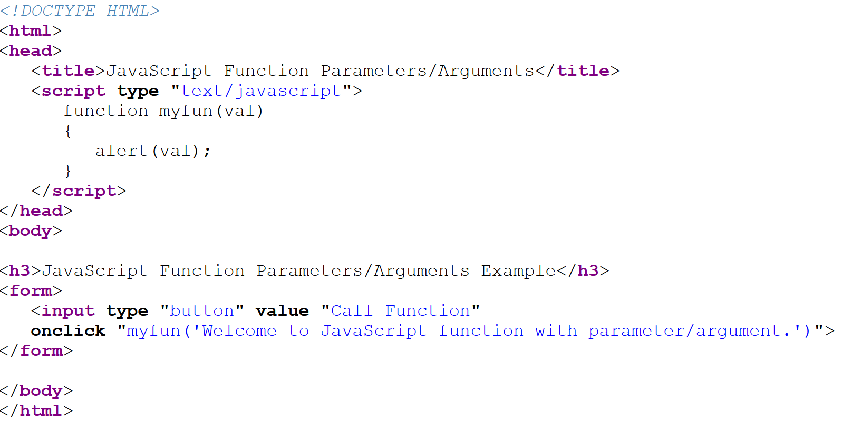

**OUTPUT**

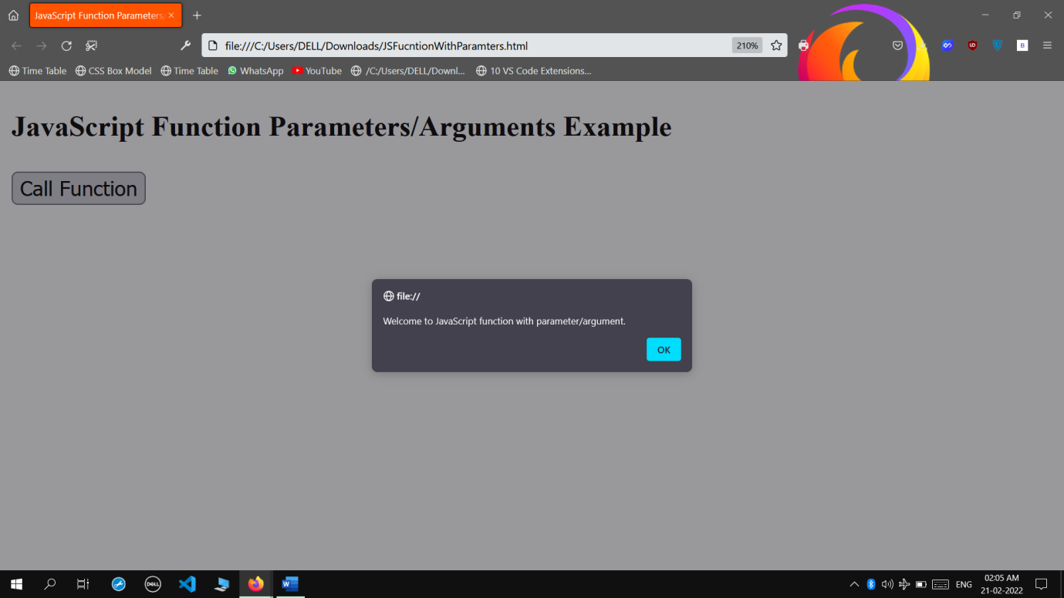

* **Java Script Object**

**INPUT**

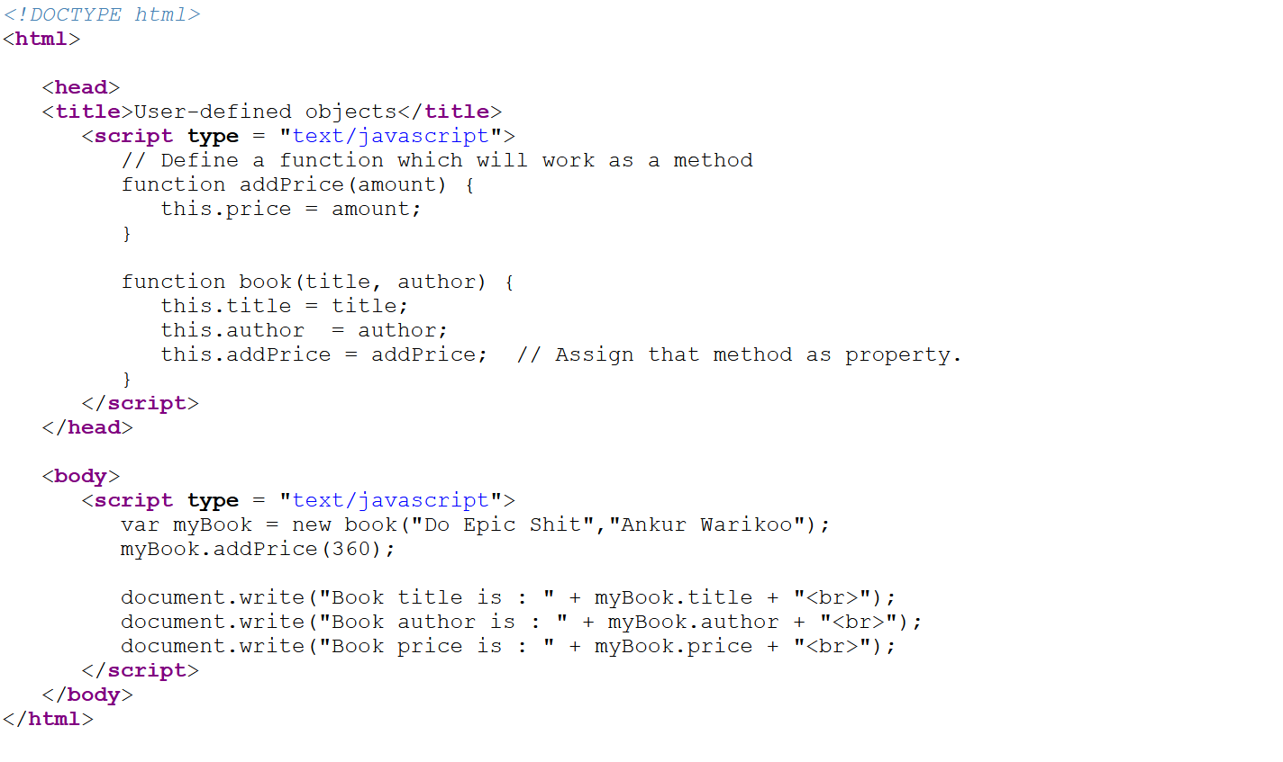

**OUTPUT**

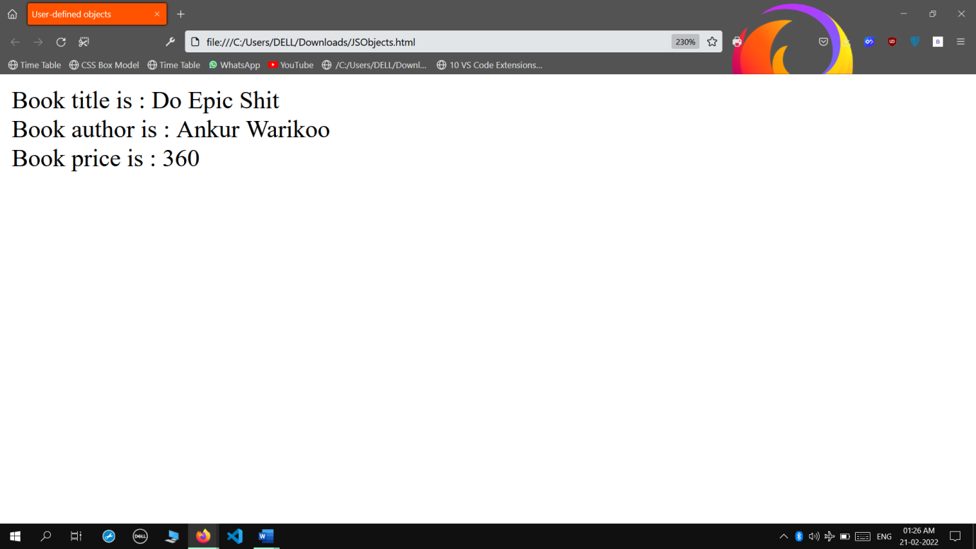

* **Java Script Event Handler-OnLoad**

**INPUT**

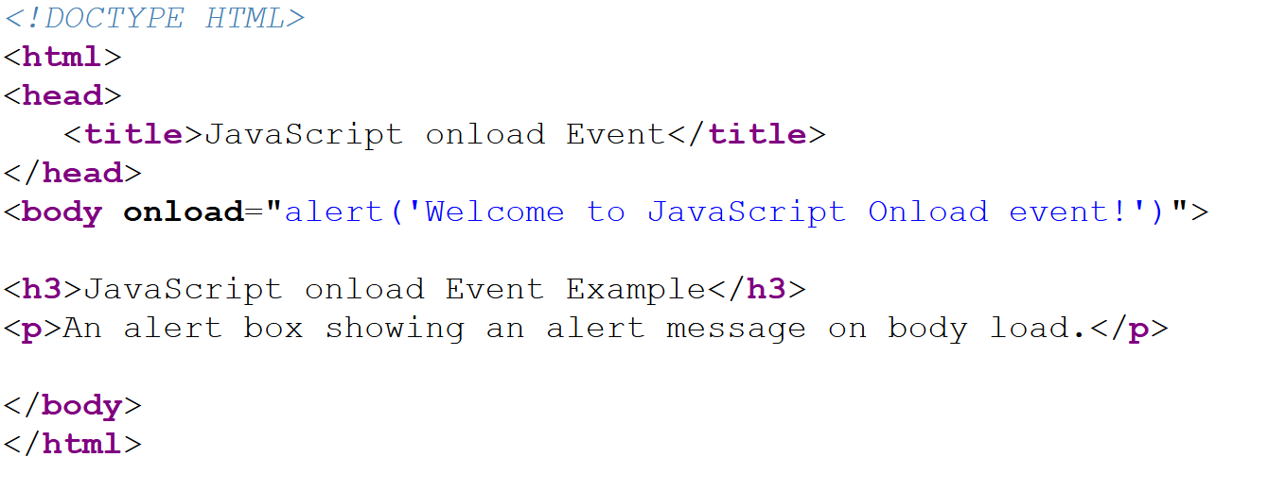

**OUTPUT**

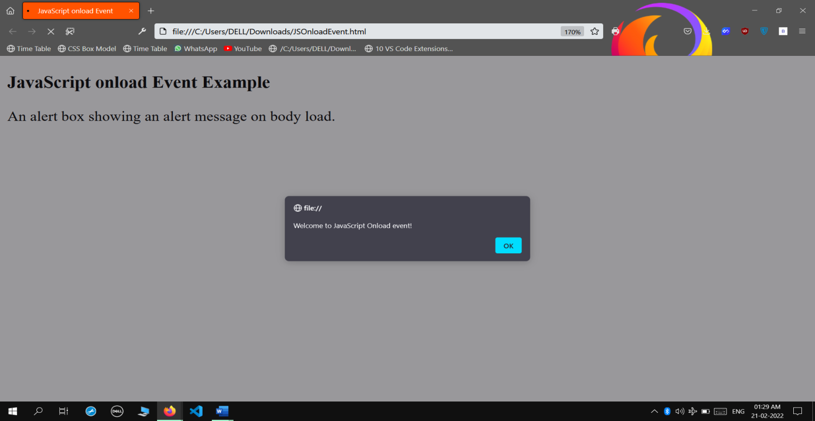

* **Java Script Event Handler-OnFocus**

**INPUT**

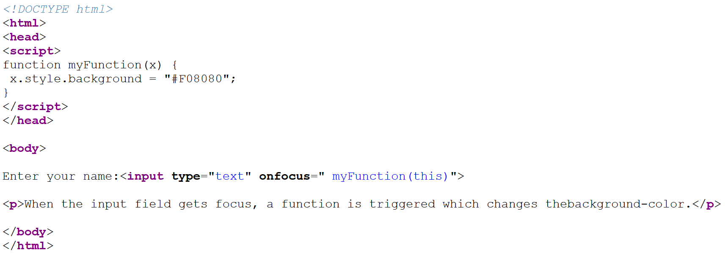

**OUTPUT**

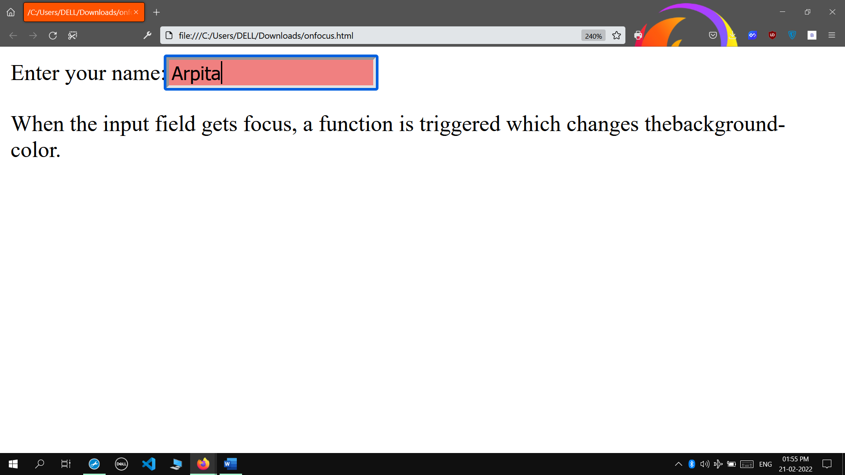

* **Java Script Event Handler-OnSubmit**

**INPUT**

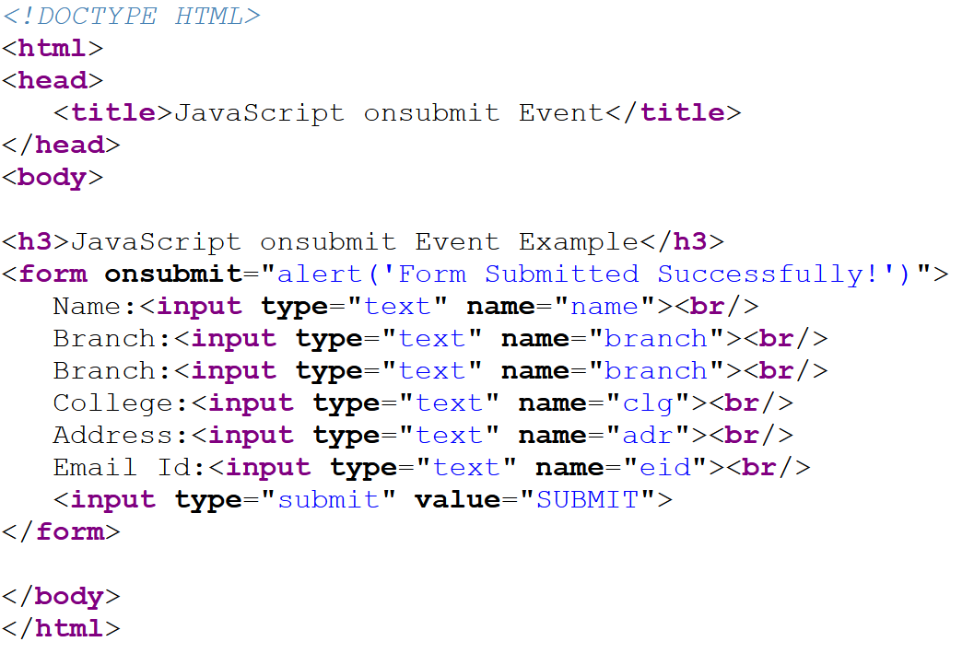

**OUTPUT**

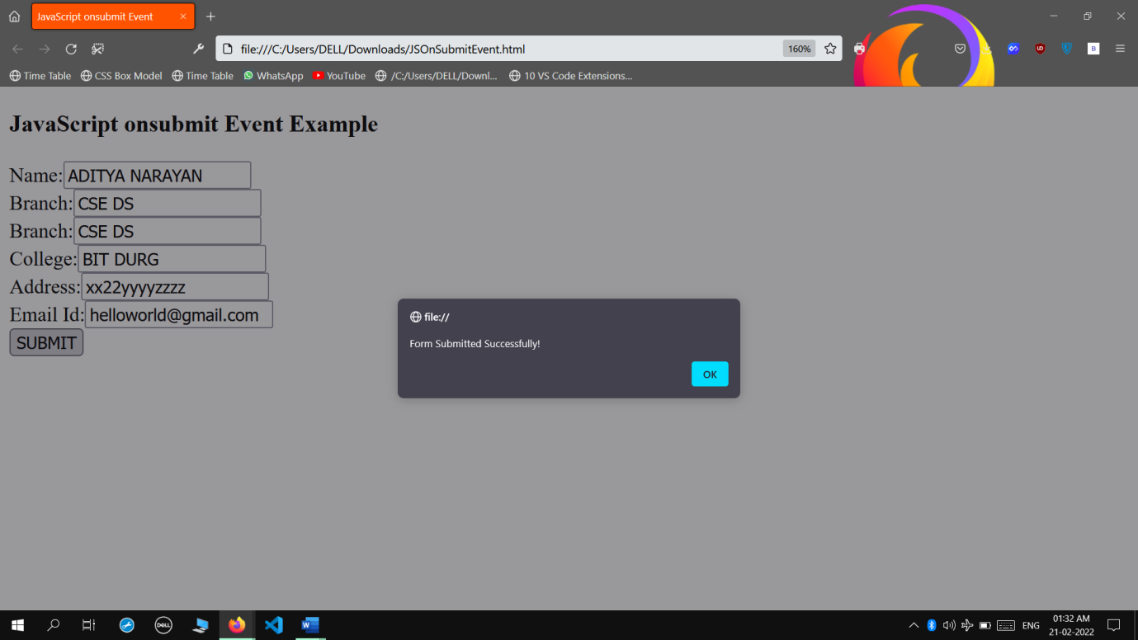

* **Java Script Event Handler-OnClick**

**INPUT**

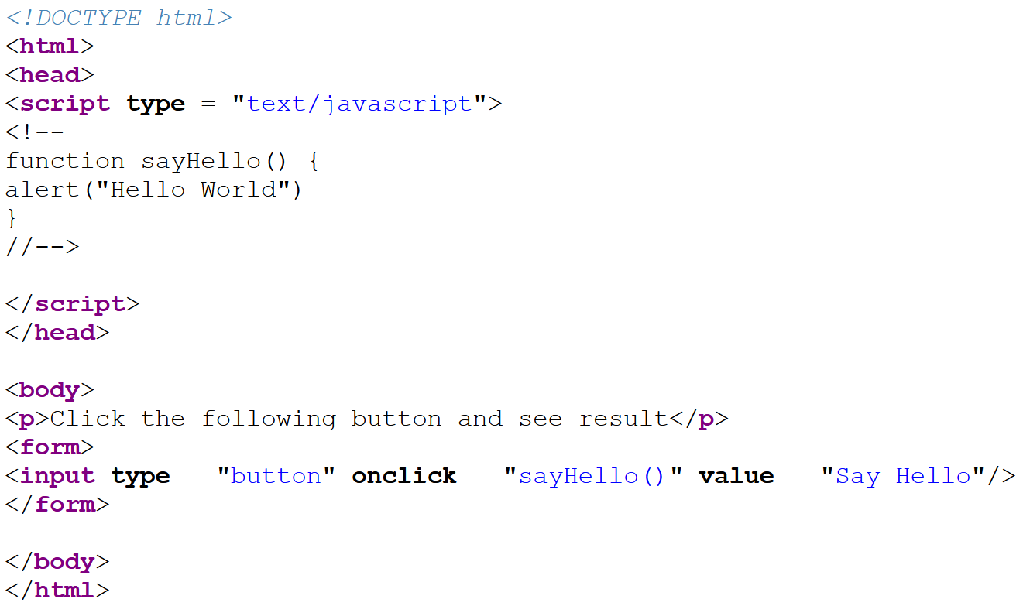

**OUTPUT**

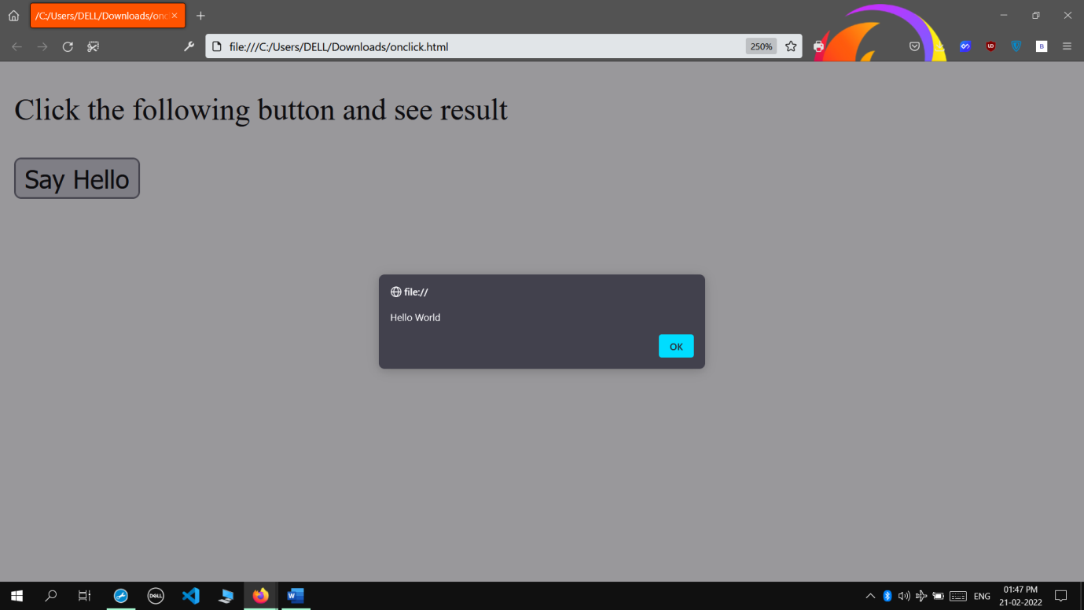

* **Java Script Event Handler-OnChange1**

**INPUT**

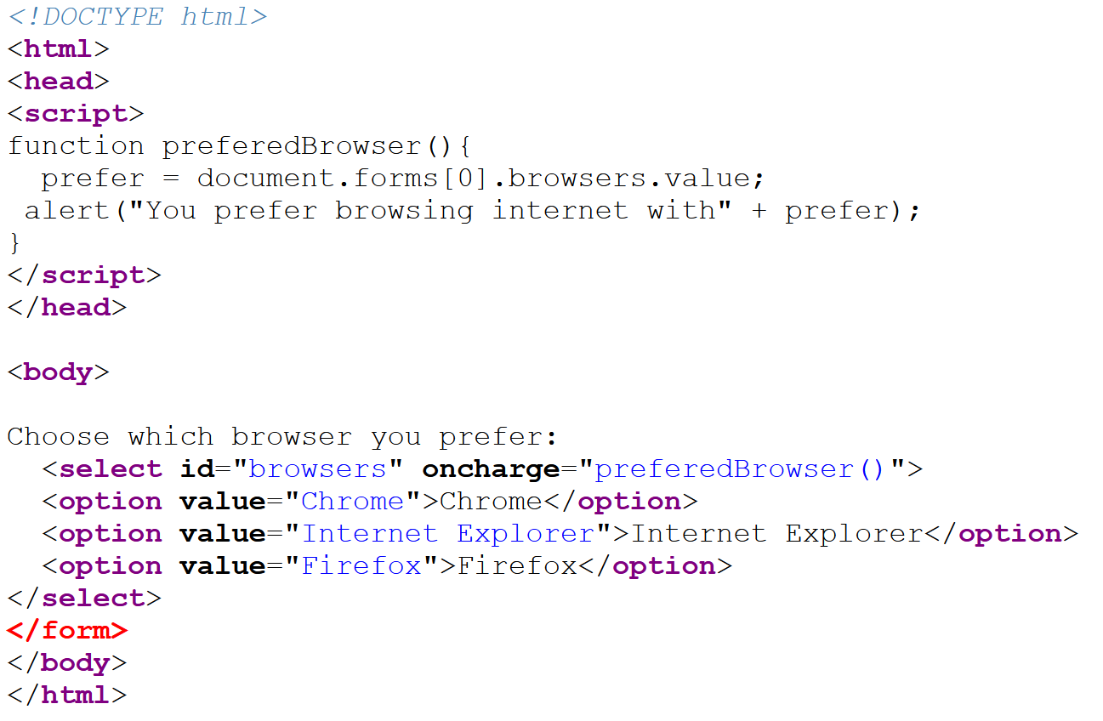

**OUTPUT**

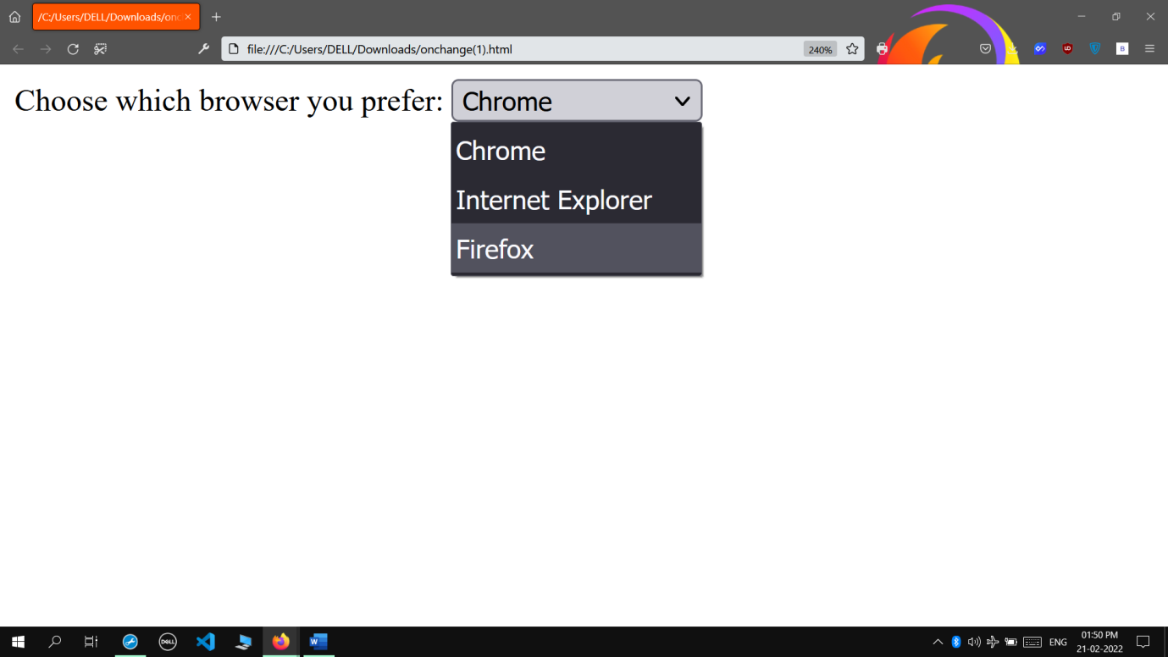

* **Java Script Event Handler-OnChange 2**

**INPUT**

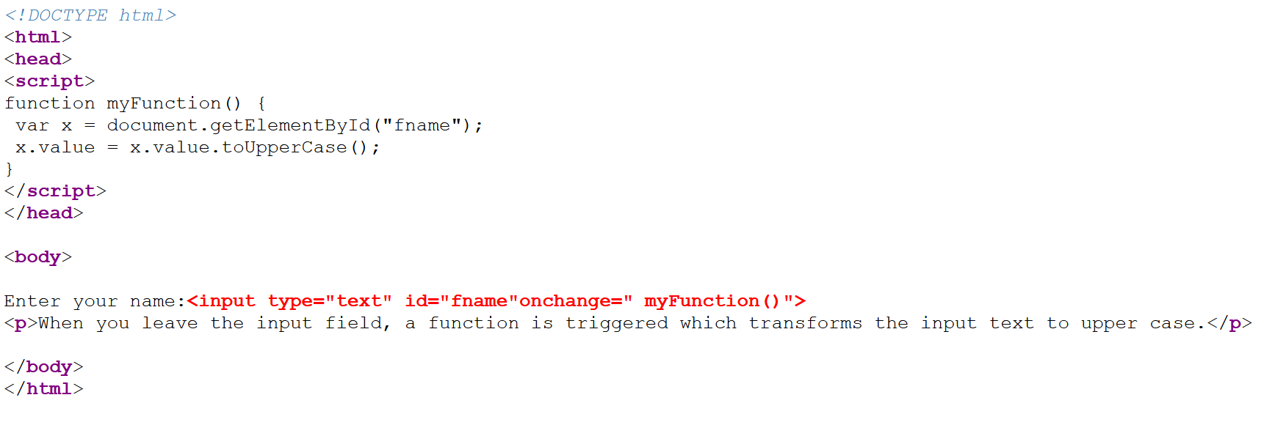

**OUTPUT**

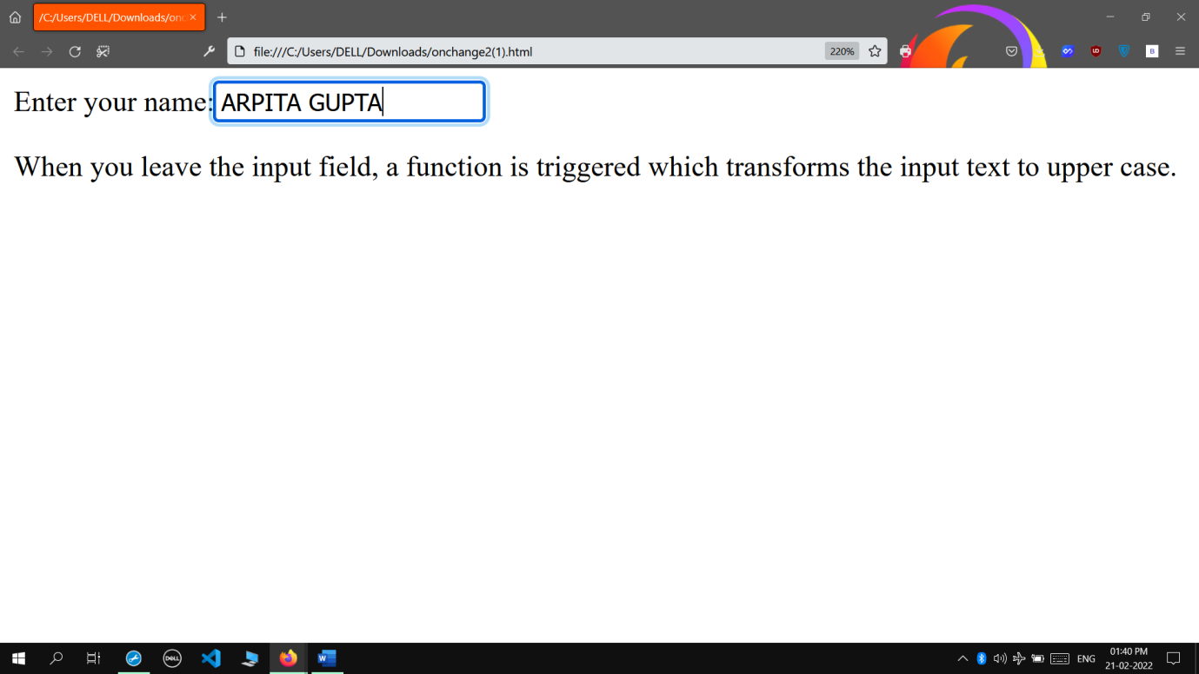

* **Java Script Event Handler-OnMouseOver**

**INPUT**

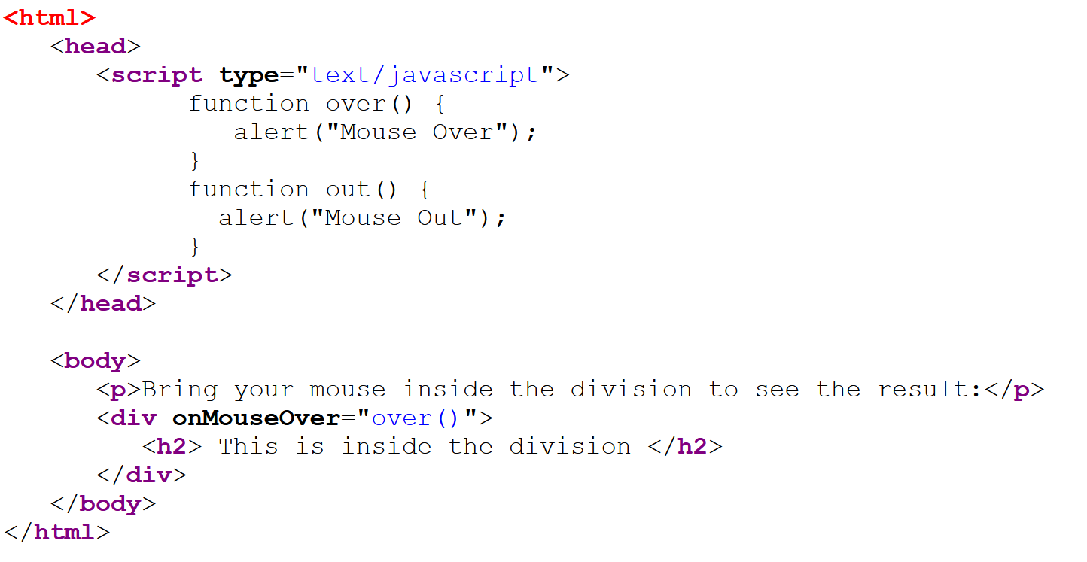

**OUTPUT**

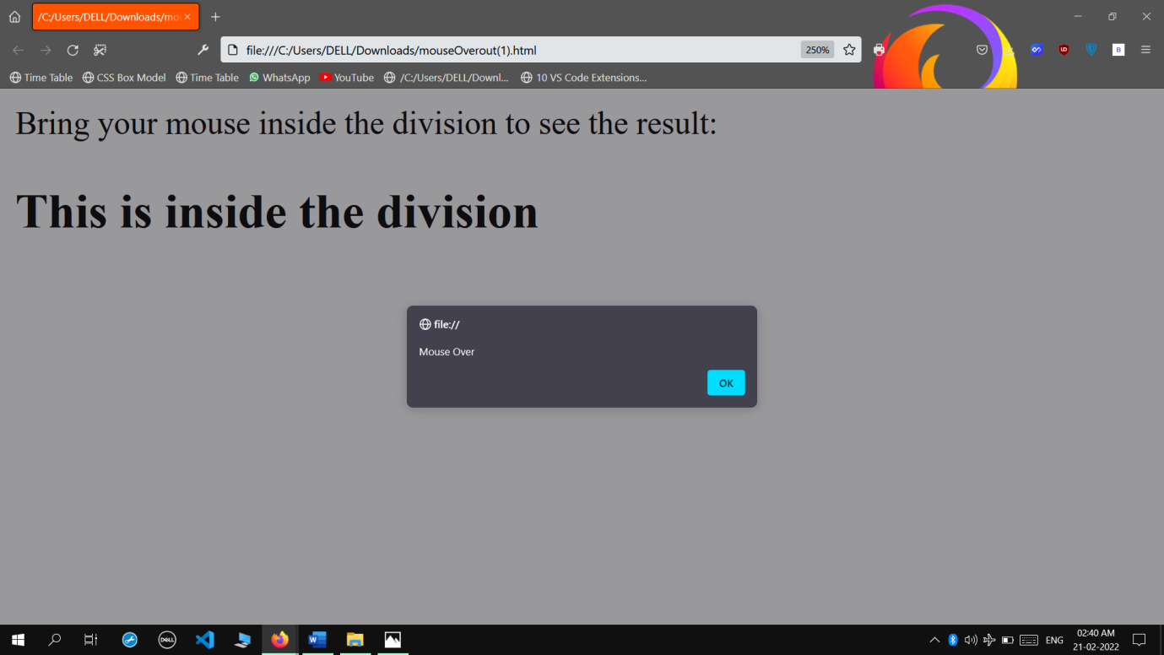

* **Java Script Event Handler-OnBlur 1**

**INPUT**

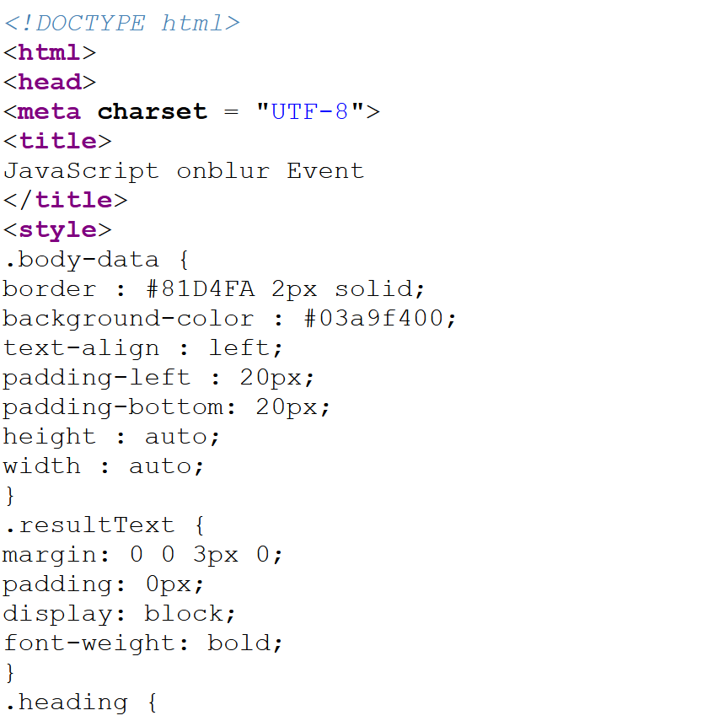

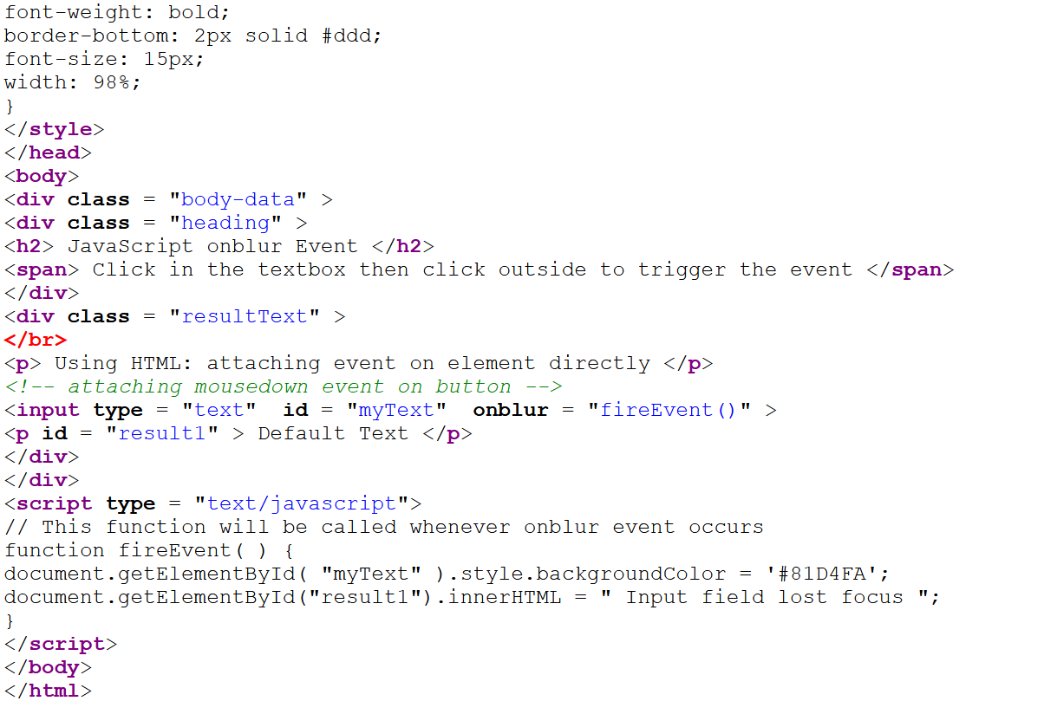

**OUTPUT**

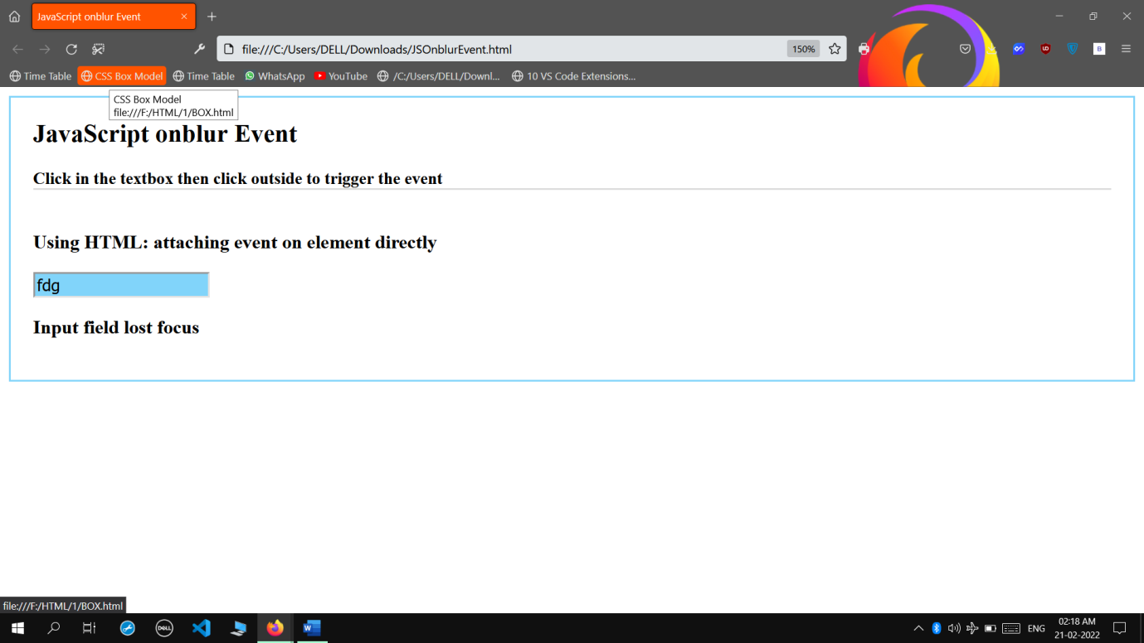

* **Java Script Event Handler-OnBlur2**

**INPUT**

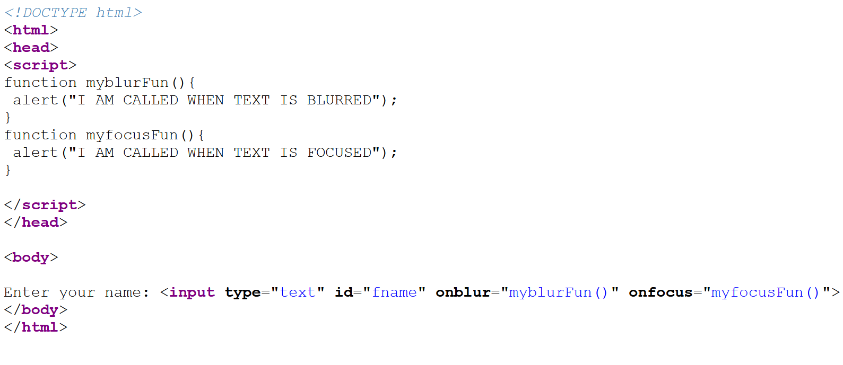

**OUTPUT**

